

Mobile Application Development  
2025-26

**Name**: Priyansh Nandan

**Registration** **Number**: 230953450

**Section**: CCE-D2

**Roll Number**: 50

Index

|  |  |  |
| --- | --- | --- |
| **S.No.** | **Title** | **Date** |
| 01 | Lab1- Basics of Android Mobile Application Development Tools | 08/01/26 |
| 02 | Lab2- Introduction to Activities and Layouts in Android | 15/01/26 |
| 03 | Lab3- Activities and Layouts continued | 22/01/26 |
| 04 | Lab4- Input Controls in Android | 29/01/26 |
|  |  |  |
|  |  |  |
|  |  |  |
|  |  |  |

**Lab 1- Basics of Android Mobile Application Development**

Question 1:

Create an Android application to show the demo of displaying text with justifying elements, changing text colors, fonts etc.

Layout Design

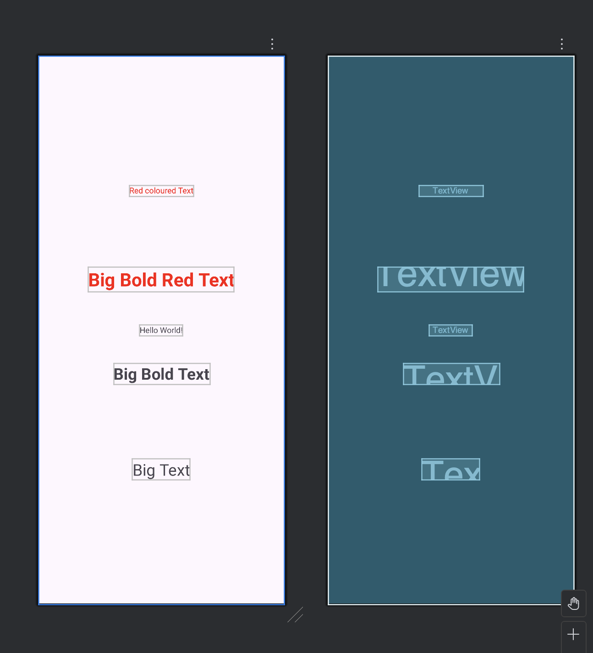

XML for activity_main

<TextView  
 android:id="@+id/textView5"  
 android:layout_width="wrap_content"  
 android:layout_height="wrap_content"  
 android:text="@string/BoldRed"  
 android:textColor="@color/red"  
 android:textSize="32sp"  
 android:textStyle="bold"  
 app:layout_constraintBottom_toTopOf="@+id/tv4"  
 app:layout_constraintEnd_toEndOf="parent"  
 app:layout_constraintStart_toStartOf="parent"  
 app:layout_constraintTop_toBottomOf="@+id/tv1" />

XML for colors

<?xml version="1.0" encoding="utf-8"?>  
<resources>  
 <color name="black">#FF000000</color>  
 <color name="white">#FFFFFFFF</color>  
 <color name="red">#FF0000</color>  
</resources>

XML for strings

<resources>  
 <string name="app_name">Question1</string>  
 <string name="RedColored">Red coloured Text</string>  
 <string name="BigText">Big Text</string>  
 <string name="BoldText">Big Bold Text</string>  
 <string name="BoldRed">Big Bold Red Text</string>  
</resources>

Output:

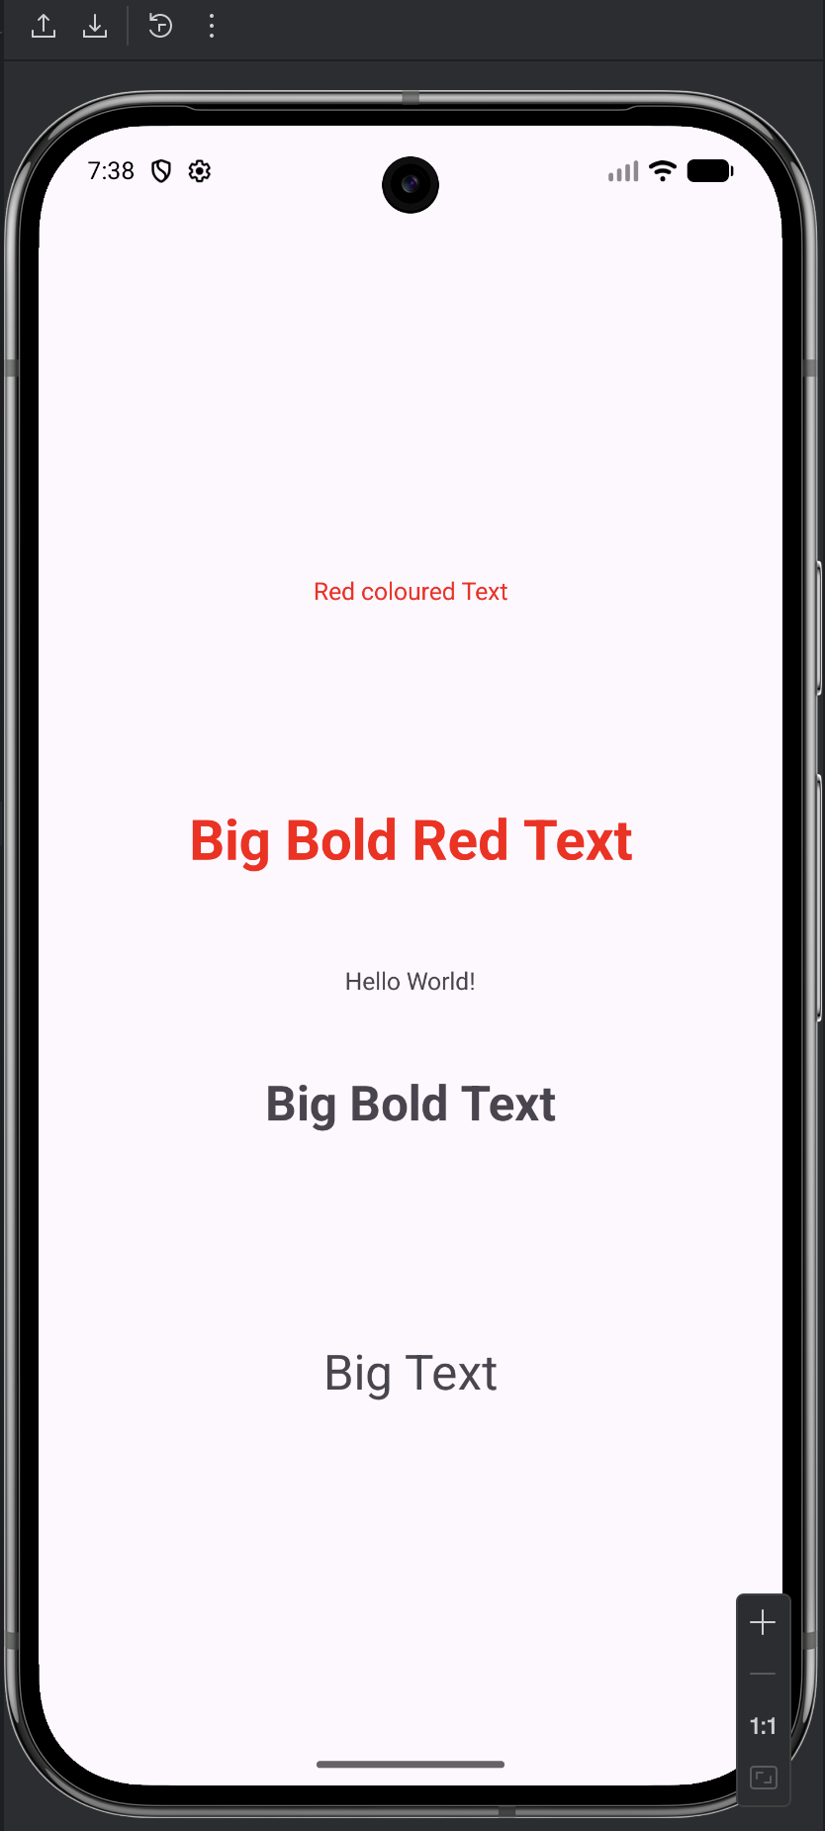

Question 2:

Find the “hello word” text in the XML document and modify the text.

Layout Design

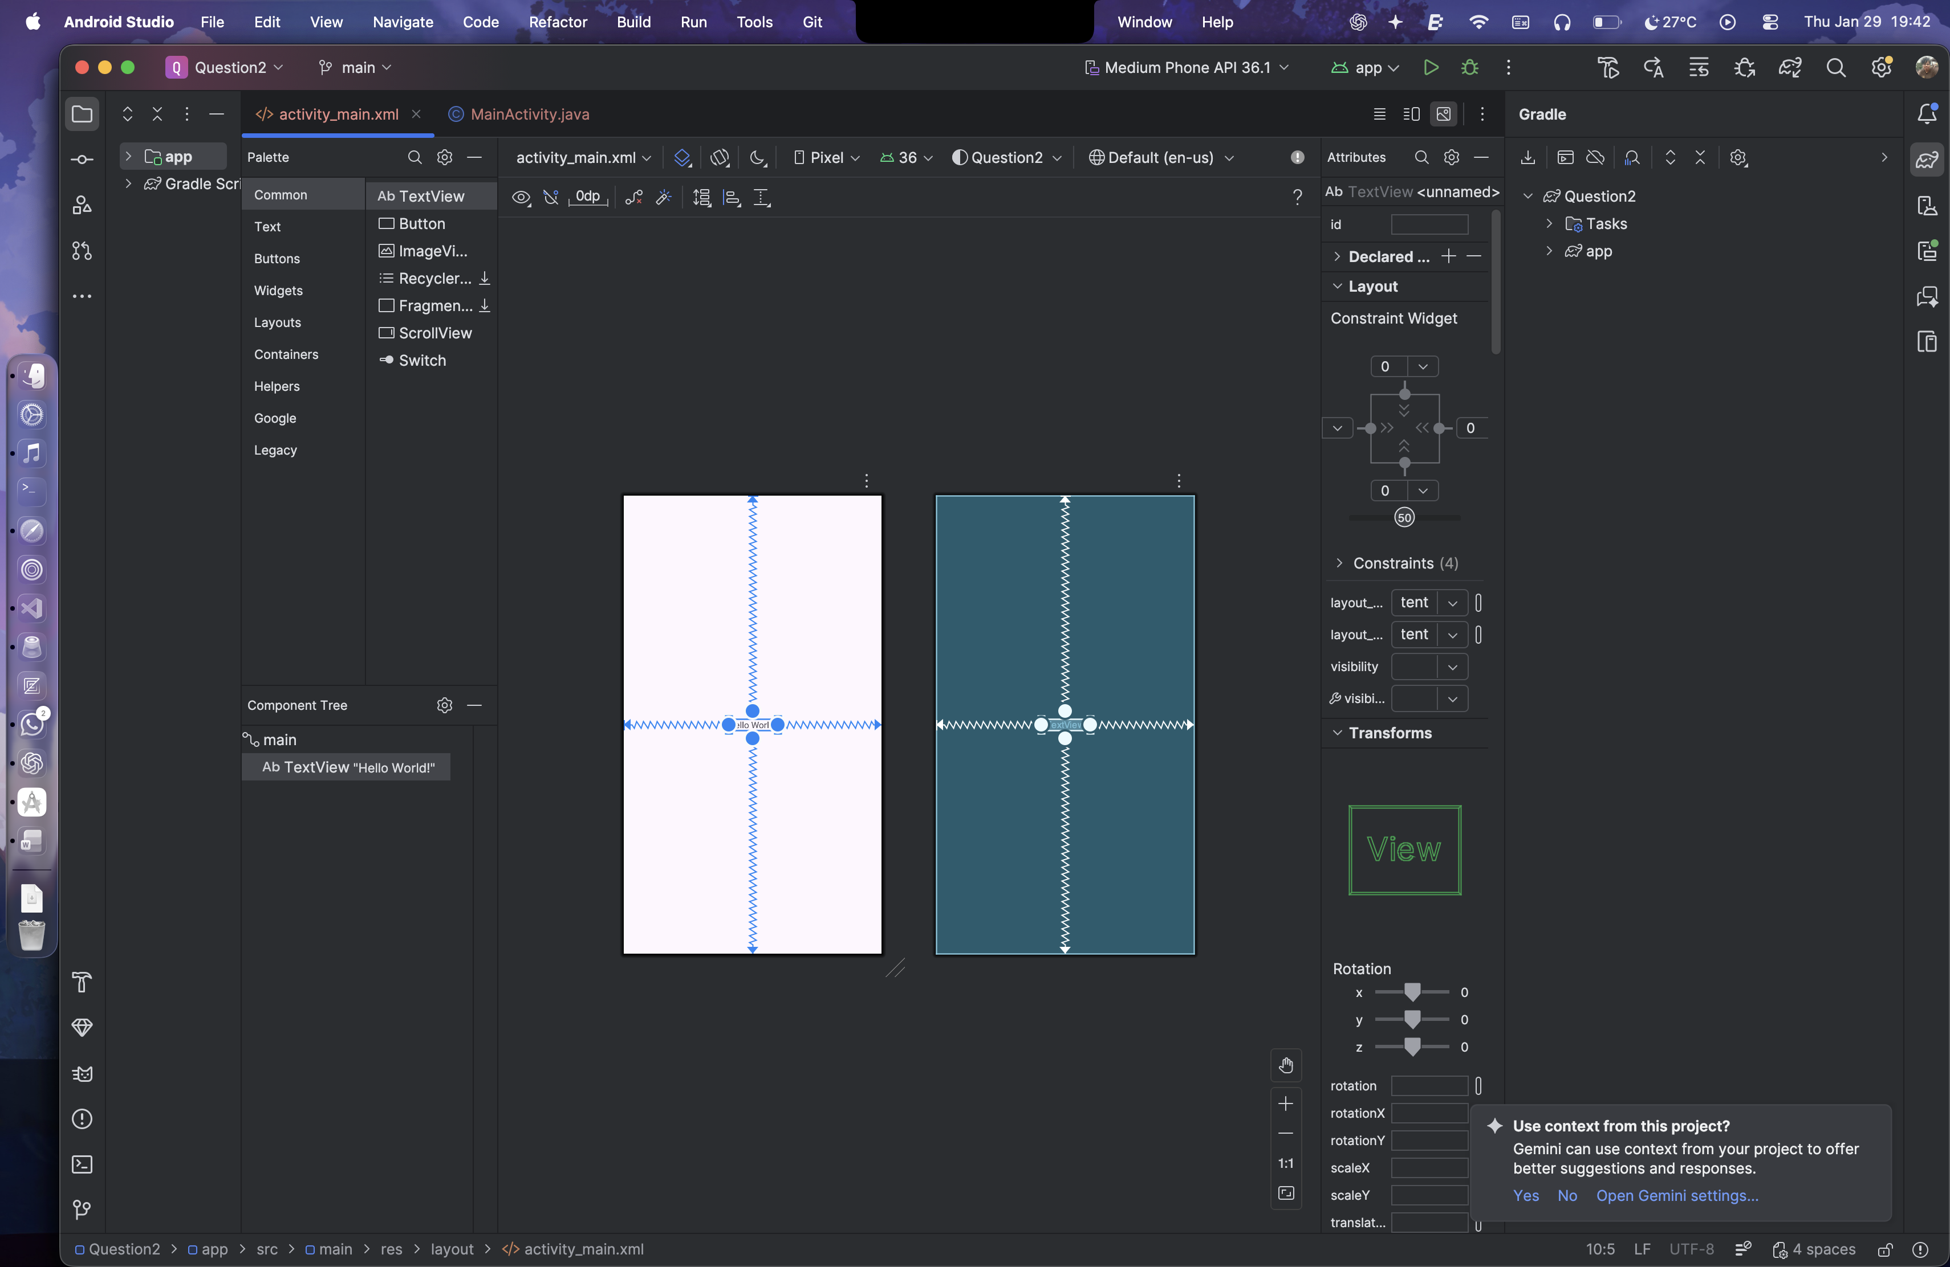

XML for activity_main

<?xml version="1.0" encoding="utf-8"?>  
<androidx.constraintlayout.widget.ConstraintLayout xmlns:android="http://schemas.android.com/apk/res/android"  
 xmlns:app="http://schemas.android.com/apk/res-auto"  
 xmlns:tools="http://schemas.android.com/tools"  
 android:id="@+id/main"  
 android:layout_width="match_parent"  
 android:layout_height="match_parent"  
 tools:context=".MainActivity">  
  
 <TextView  
 android:layout_width="wrap_content"  
 android:layout_height="wrap_content"  
 android:text="@string/q2"  
 app:layout_constraintBottom_toBottomOf="parent"  
 app:layout_constraintEnd_toEndOf="parent"  
 app:layout_constraintStart_toStartOf="parent"  
 app:layout_constraintTop_toTopOf="parent" />  
  
</androidx.constraintlayout.widget.ConstraintLayout>

Output:

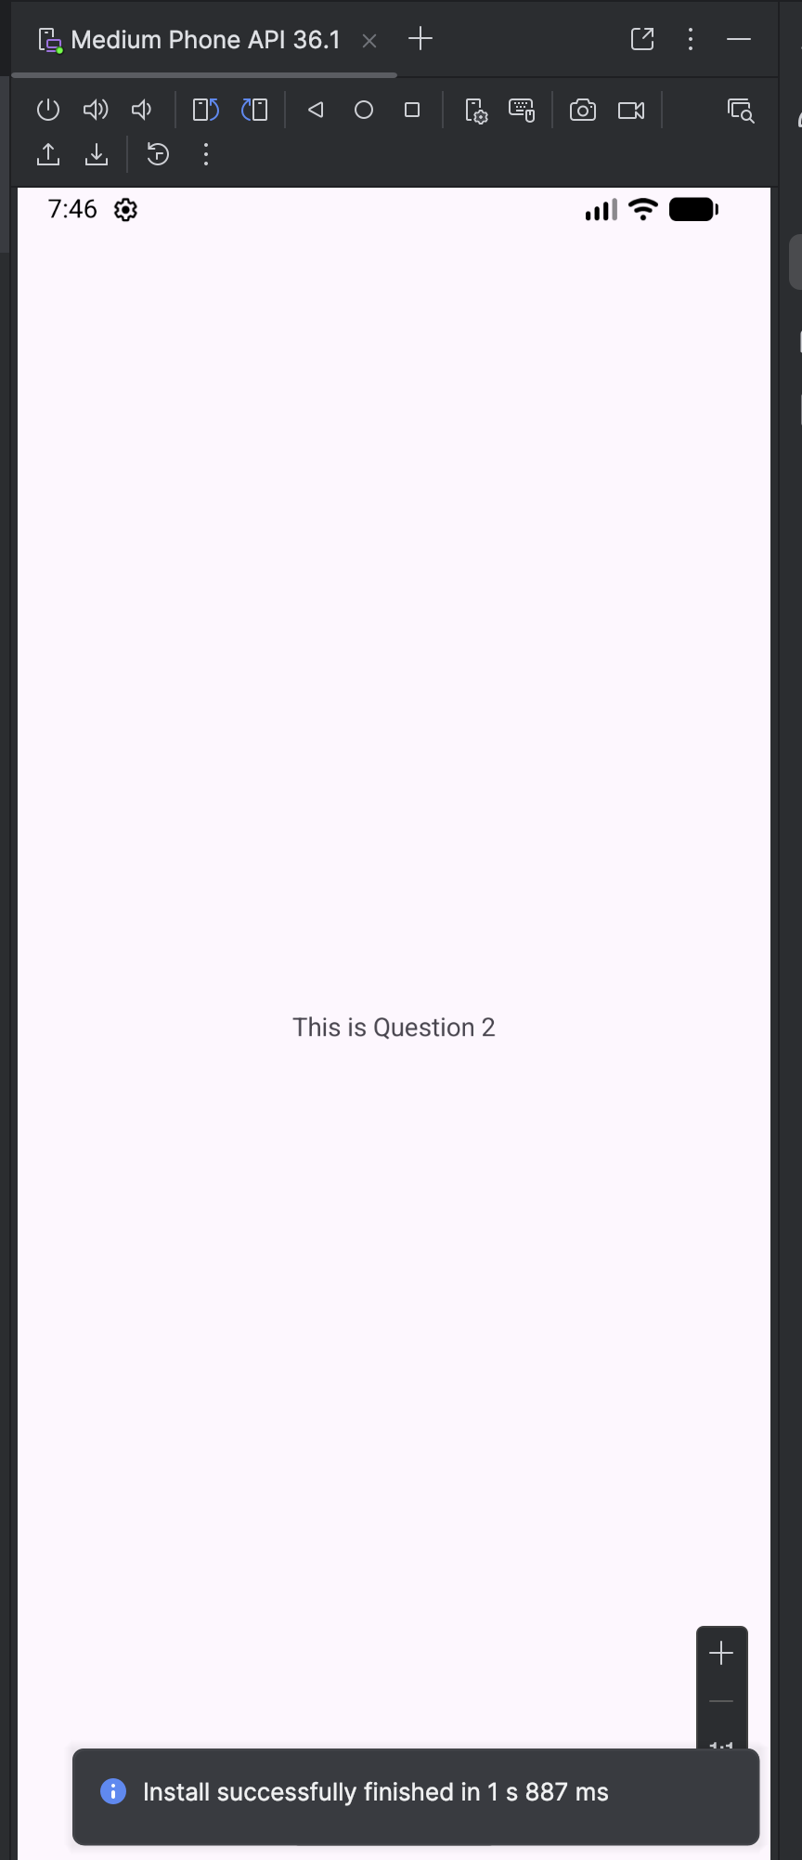

**Lab 2- Introduction to Activities and Layouts in Android**

Question 1:

Create an app that illustrates that the activity lifecycle method being triggered by various action. Understand when onCreate(),onStart(),onResume event occur.

Layout Design:

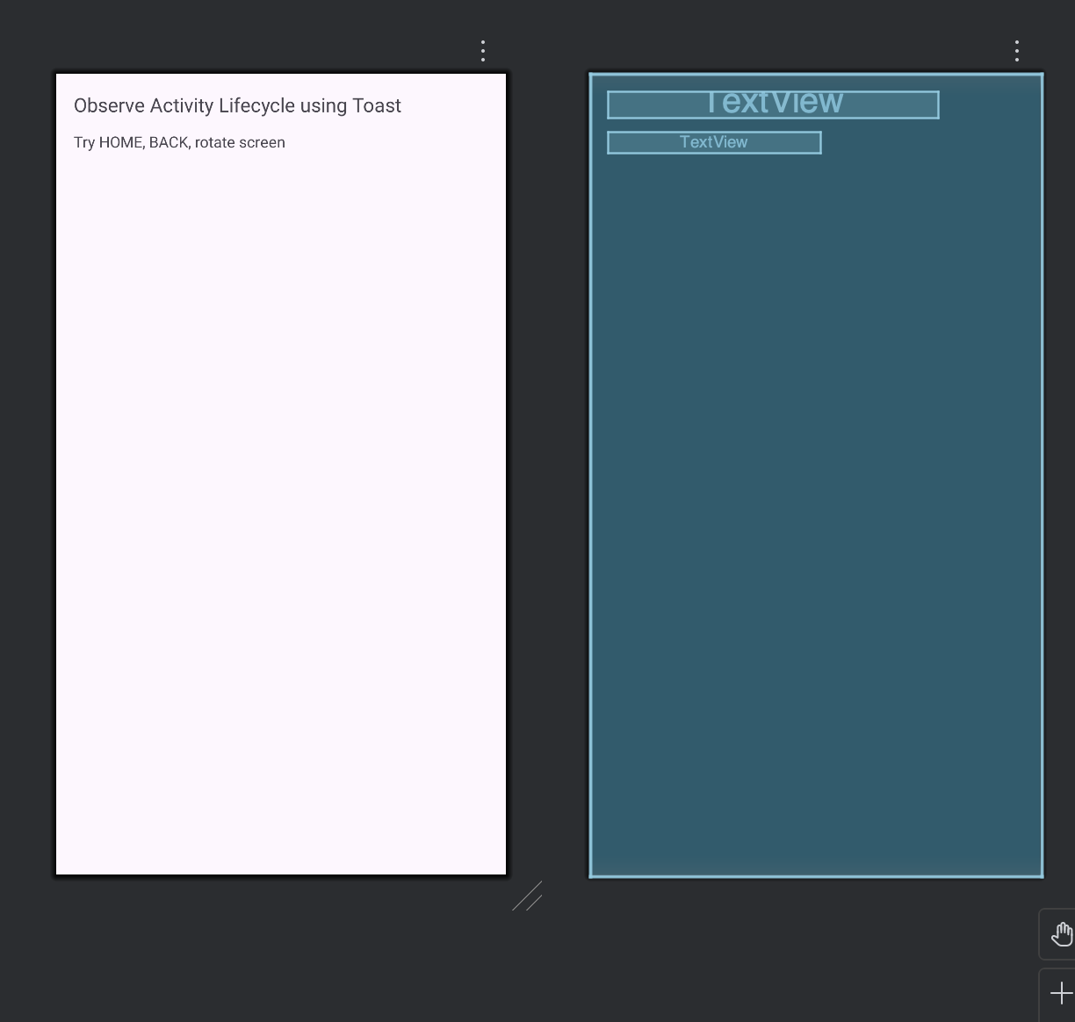

XML for Activity:

<?xml version="1.0" encoding="utf-8"?>  
<LinearLayout xmlns:android="http://schemas.android.com/apk/res/android"  
 android:layout_width="match_parent"  
 android:layout_height="match_parent"  
 android:orientation="vertical"  
 android:padding="16dp">  
  
 <TextView  
 android:layout_width="wrap_content"  
 android:layout_height="wrap_content"  
 android:text="Observe Activity Lifecycle using Toast"  
 android:textSize="18sp"/>  
  
 <TextView  
 android:layout_width="wrap_content"  
 android:layout_height="wrap_content"  
 android:text="Try HOME, BACK, rotate screen"  
 android:layout_marginTop="12dp"/>  
  
</LinearLayout>

Java Code:

package com.example.question1;  
  
import androidx.appcompat.app.AppCompatActivity;  
import android.os.Bundle;  
import android.util.Log;  
import android.widget.Toast;  
  
public class MainActivity extends AppCompatActivity {  
  
 String TAG = "LifecycleDemo";  
  
 @Override  
 protected void onCreate(Bundle savedInstanceState) {  
 super.onCreate(savedInstanceState);  
 setContentView(R.layout.*activity_main*);  
 Toast.*makeText*(this, "onCreate()", Toast.*LENGTH_SHORT*).show();  
 Log.*d*(TAG, "onCreate");  
 }  
  
 @Override  
 protected void onStart() {  
 super.onStart();  
 Toast.*makeText*(this, "onStart()", Toast.*LENGTH_SHORT*).show();  
 Log.*d*(TAG, "onStart");  
 }  
  
 @Override  
 protected void onResume() {  
 super.onResume();  
 Toast.*makeText*(this, "onResume()", Toast.*LENGTH_SHORT*).show();  
 Log.*d*(TAG, "onResume");  
 }  
  
 @Override  
 protected void onPause() {  
 super.onPause();  
 Toast.*makeText*(this, "onPause()", Toast.*LENGTH_SHORT*).show();  
 Log.*d*(TAG, "onPause");  
 }  
  
 @Override  
 protected void onStop() {  
 super.onStop();  
 Toast.*makeText*(this, "onStop()", Toast.*LENGTH_SHORT*).show();  
 Log.*d*(TAG, "onStop");  
 }  
  
 @Override  
 protected void onRestart() {  
 super.onRestart();  
 Toast.*makeText*(this, "onRestart()", Toast.*LENGTH_SHORT*).show();  
 Log.*d*(TAG, "onRestart");  
 }  
  
 @Override  
 protected void onDestroy() {  
 super.onDestroy();  
 Toast.*makeText*(this, "onDestroy()", Toast.*LENGTH_SHORT*).show();  
 Log.*d*(TAG, "onDestroy");  
 }  
}

Output:

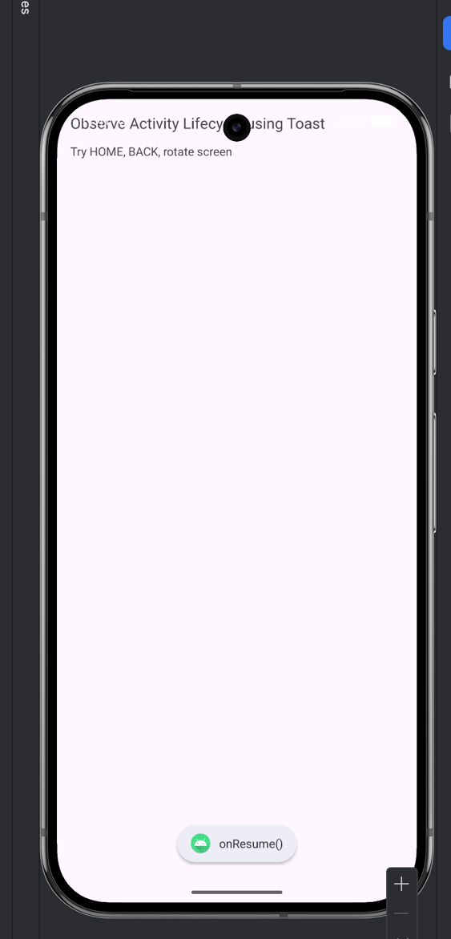

Question 2:

Create a Calculator app that does the function of multiplication, addition, division, subtraction but displays the result in the format of:-Num1 operator num2 = result. Back button on the next activity should get back to the calculator activity again.

Layout Design

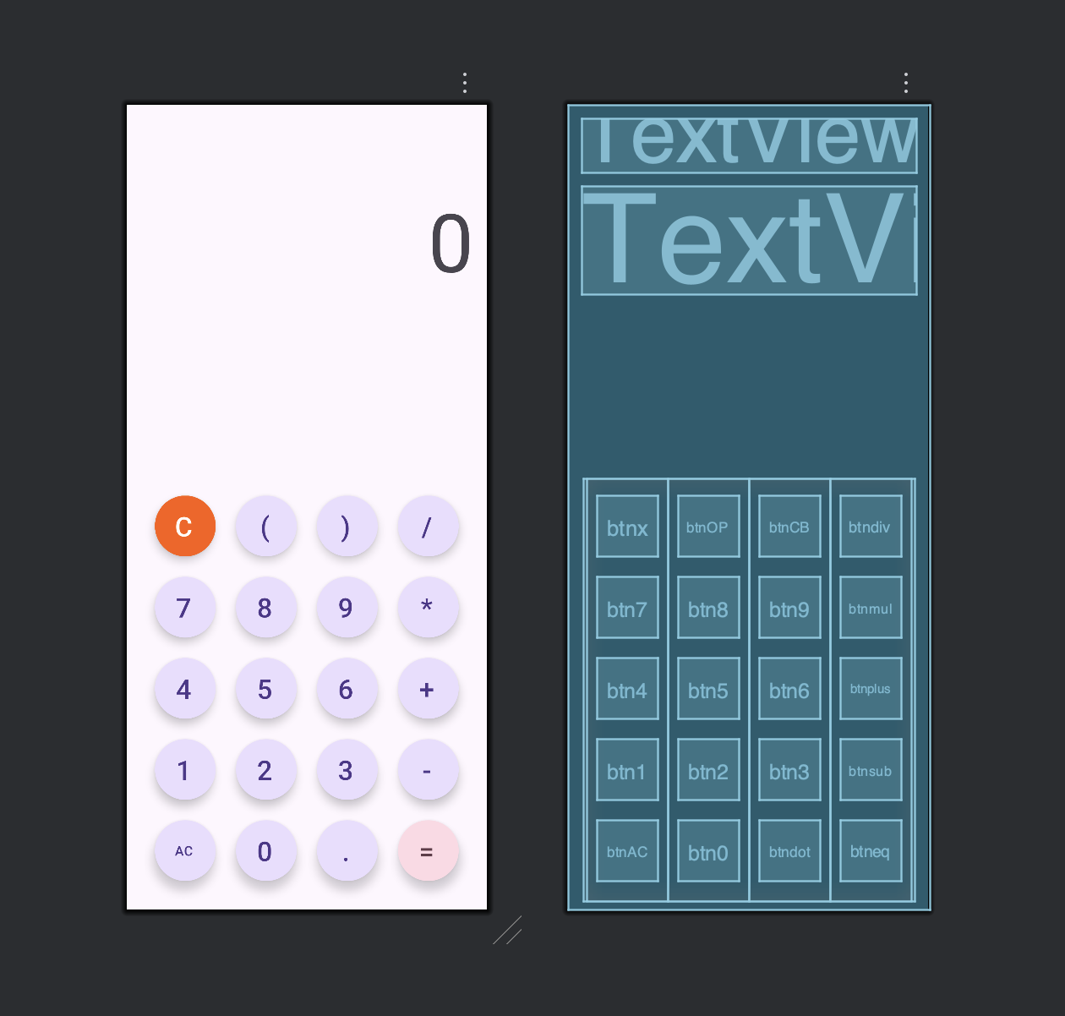

XML for activity_main

<?xml version="1.0" encoding="utf-8"?>  
<androidx.constraintlayout.widget.ConstraintLayout xmlns:android="http://schemas.android.com/apk/res/android"  
 xmlns:app="http://schemas.android.com/apk/res-auto"  
 xmlns:tools="http://schemas.android.com/tools"  
 android:id="@+id/main"  
 android:layout_width="match_parent"  
 android:layout_height="match_parent"  
 tools:context=".MainActivity">  
  
 <TextView  
 android:id="@+id/calc"  
 android:layout_width="match_parent"  
 android:layout_height="wrap_content"  
 android:layout_margin="16dp"  
 android:layout_marginTop="168dp"  
 android:textSize="48sp"  
 app:layout_constraintEnd_toEndOf="parent"  
 app:layout_constraintHorizontal_bias="0.692"  
 app:layout_constraintStart_toStartOf="parent"  
 app:layout_constraintTop_toTopOf="parent" />  
  
  
 <TextView  
 android:id="@+id/res"  
 android:layout_width="match_parent"  
 android:layout_height="wrap_content"  
 android:layout_margin="16dp"  
 android:text="@string/txt0"  
 android:textAlignment="viewEnd"  
 android:textSize="96sp"  
 app:layout_constraintTop_toBottomOf="@+id/calc"  
 tools:layout_editor_absoluteX="23dp" />  
  
 <LinearLayout  
 android:layout_width="392dp"  
 android:layout_height="499dp"  
 android:layout_margin="12dp"  
 android:gravity="center"  
 android:orientation="horizontal"  
 app:layout_constraintBottom_toBottomOf="parent"  
 app:layout_constraintEnd_toEndOf="parent"  
 app:layout_constraintStart_toStartOf="parent">  
  
 <LinearLayout  
 android:layout_width="wrap_content"  
 android:layout_height="match_parent"  
 android:gravity="center"  
 android:orientation="vertical">  
  
  
 <com.google.android.material.button.MaterialButton  
 android:id="@+id/btnx"  
 style="@style/Widget.Material3.ExtendedFloatingActionButton.Icon.Primary"  
 android:layout_width="72dp"  
 android:layout_height="72dp"  
 android:layout_margin="12dp"  
 android:backgroundTint="#FF5C00"  
 android:text="@string/btnC"  
 android:textAlignment="center"  
 android:textColor="#FFFFFF"  
 android:textSize="32sp"  
 app:cornerRadius="36dp" />  
  
 <com.google.android.material.button.MaterialButton  
 android:id="@+id/btn7"  
 style="@style/Widget.Material3.ExtendedFloatingActionButton.Icon.Primary"  
 android:layout_width="72dp"  
 android:layout_height="72dp"  
 android:layout_margin="12dp"  
 android:text="@string/btn7"  
 android:textSize="32sp"  
 app:cornerRadius="36dp" />  
  
 <com.google.android.material.button.MaterialButton  
 android:id="@+id/btn4"  
 style="@style/Widget.Material3.ExtendedFloatingActionButton.Icon.Primary"  
 android:layout_width="72dp"  
 android:layout_height="72dp"  
 android:layout_margin="12dp"  
 android:text="@string/btn4"  
 android:textSize="32sp"  
 app:cornerRadius="36dp" />  
  
 <com.google.android.material.button.MaterialButton  
 android:id="@+id/btn1"  
 style="@style/Widget.Material3.ExtendedFloatingActionButton.Icon.Primary"  
 android:layout_width="72dp"  
 android:layout_height="72dp"  
 android:layout_margin="12dp"  
 android:text="@string/btn1"  
 android:textSize="32sp"  
 app:cornerRadius="36dp" />  
  
 <com.google.android.material.button.MaterialButton  
 android:id="@+id/btnAC"  
 style="@style/Widget.Material3.ExtendedFloatingActionButton.Icon.Primary"  
 android:layout_width="72dp"  
 android:layout_height="72dp"  
 android:layout_margin="12dp"  
 android:text="@string/btnAC"  
 android:textSize="16sp"  
 app:cornerRadius="36dp" />  
  
  
 </LinearLayout>  
  
 <LinearLayout  
 android:layout_width="wrap_content"  
 android:layout_height="match_parent"  
 android:gravity="center"  
 android:orientation="vertical">  
  
 <com.google.android.material.button.MaterialButton  
 android:id="@+id/btnOP"  
 style="@style/Widget.Material3.ExtendedFloatingActionButton.Icon.Primary"  
 android:layout_width="72dp"  
 android:layout_height="72dp"  
 android:layout_margin="12dp"  
 android:text="@string/btnOB"  
 android:textSize="32sp"  
 app:cornerRadius="36dp" />  
  
 <com.google.android.material.button.MaterialButton  
 android:id="@+id/btn8"  
 style="@style/Widget.Material3.ExtendedFloatingActionButton.Icon.Primary"  
 android:layout_width="72dp"  
 android:layout_height="72dp"  
 android:layout_margin="12dp"  
 android:text="@string/btn8"  
 android:textSize="32sp"  
 app:cornerRadius="36dp" />  
  
 <com.google.android.material.button.MaterialButton  
 android:id="@+id/btn5"  
 style="@style/Widget.Material3.ExtendedFloatingActionButton.Icon.Primary"  
 android:layout_width="72dp"  
 android:layout_height="72dp"  
 android:layout_margin="12dp"  
 android:text="@string/btn5"  
 android:textSize="32sp"  
 app:cornerRadius="36dp" />  
  
 <com.google.android.material.button.MaterialButton  
 android:id="@+id/btn2"  
 style="@style/Widget.Material3.ExtendedFloatingActionButton.Icon.Primary"  
 android:layout_width="72dp"  
 android:layout_height="72dp"  
 android:layout_margin="12dp"  
 android:text="@string/btn2"  
 android:textSize="32sp"  
 app:cornerRadius="36dp" />  
  
 <com.google.android.material.button.MaterialButton  
 android:id="@+id/btn0"  
 style="@style/Widget.Material3.ExtendedFloatingActionButton.Icon.Primary"  
 android:layout_width="72dp"  
 android:layout_height="72dp"  
 android:layout_margin="12dp"  
 android:text="@string/btn0"  
 android:textSize="32sp"  
 app:cornerRadius="36dp" />  
 </LinearLayout>  
  
 <LinearLayout  
 android:layout_width="wrap_content"  
 android:layout_height="match_parent"  
 android:gravity="center"  
 android:orientation="vertical">  
  
 <com.google.android.material.button.MaterialButton  
 android:id="@+id/btnCB"  
 style="@style/Widget.Material3.ExtendedFloatingActionButton.Icon.Primary"  
 android:layout_width="72dp"  
 android:layout_height="72dp"  
 android:layout_margin="12dp"  
 android:text="@string/btnCB"  
 android:textSize="32dp"  
 app:cornerRadius="36dp" />  
  
 <com.google.android.material.button.MaterialButton  
 android:id="@+id/btn9"  
 style="@style/Widget.Material3.ExtendedFloatingActionButton.Icon.Primary"  
 android:layout_width="72dp"  
 android:layout_height="72dp"  
 android:layout_margin="12dp"  
 android:text="@string/btn9"  
 android:textSize="32sp"  
 app:cornerRadius="36dp" />  
  
 <com.google.android.material.button.MaterialButton  
 android:id="@+id/btn6"  
 style="@style/Widget.Material3.ExtendedFloatingActionButton.Icon.Primary"  
 android:layout_width="72dp"  
 android:layout_height="72dp"  
 android:layout_margin="12dp"  
 android:text="@string/btn6"  
 android:textSize="32sp"  
 app:cornerRadius="36dp" />  
  
 <com.google.android.material.button.MaterialButton  
 android:id="@+id/btn3"  
 style="@style/Widget.Material3.ExtendedFloatingActionButton.Icon.Primary"  
 android:layout_width="72dp"  
 android:layout_height="72dp"  
 android:layout_margin="12dp"  
 android:text="@string/btn3"  
 android:textSize="32sp"  
 app:cornerRadius="36dp" />  
  
 <com.google.android.material.button.MaterialButton  
 android:id="@+id/btndot"  
 style="@style/Widget.Material3.ExtendedFloatingActionButton.Icon.Primary"  
 android:layout_width="72dp"  
 android:layout_height="72dp"  
 android:layout_margin="12dp"  
 android:text="@string/btndot"  
 android:textSize="32sp"  
 app:cornerRadius="36dp" />  
 </LinearLayout>  
  
 <LinearLayout  
 android:layout_width="wrap_content"  
 android:layout_height="match_parent"  
 android:gravity="center"  
 android:orientation="vertical">  
  
 <com.google.android.material.button.MaterialButton  
 android:id="@+id/btndiv"  
 style="@style/Widget.Material3.ExtendedFloatingActionButton.Icon.Primary"  
 android:layout_width="72dp"  
 android:layout_height="72dp"  
 android:layout_margin="12dp"  
 android:text="@string/btndiv"  
 android:textSize="32sp"  
 app:cornerRadius="36dp" />  
  
 <com.google.android.material.button.MaterialButton  
 android:id="@+id/btnmul"  
 style="@style/Widget.Material3.ExtendedFloatingActionButton.Icon.Primary"  
 android:layout_width="72dp"  
 android:layout_height="72dp"  
 android:layout_margin="12dp"  
 android:text="@string/btnmul"  
 android:textSize="32dp"  
 app:cornerRadius="36dp" />  
  
 <com.google.android.material.button.MaterialButton  
 android:id="@+id/btnplus"  
 style="@style/Widget.Material3.ExtendedFloatingActionButton.Icon.Primary"  
 android:layout_width="72dp"  
 android:layout_height="72dp"  
 android:layout_margin="12dp"  
 android:text="@string/btnplus"  
 android:textSize="32sp"  
 app:cornerRadius="36dp" />  
  
 <com.google.android.material.button.MaterialButton  
 android:id="@+id/btnsub"  
 style="@style/Widget.Material3.ExtendedFloatingActionButton.Icon.Primary"  
 android:layout_width="72dp"  
 android:layout_height="72dp"  
 android:layout_margin="12dp"  
 android:text="@string/btnsub"  
 android:textSize="32sp"  
 app:cornerRadius="36dp" />  
  
 <com.google.android.material.button.MaterialButton  
 android:id="@+id/btneq"  
 style="@style/Widget.Material3.ExtendedFloatingActionButton.Icon.Tertiary"  
 android:layout_width="72dp"  
 android:layout_height="72dp"  
 android:layout_margin="12dp"  
 android:text="@string/btneq"  
 android:textSize="32sp"  
 app:cornerRadius="36dp" />  
  
 </LinearLayout>  
  
 </LinearLayout>  
  
</androidx.constraintlayout.widget.ConstraintLayout>

XML for strings

<resources>  
 <string name="app_name">Calculator</string>  
 <string name="txt0">0</string>  
 <string name="btnAC">AC</string>  
 <string name="btnOB">(</string>  
 <string name="btnCB">)</string>  
 <string name="btnC"> C </string>  
 <string name="btn7">7</string>  
 <string name="btn8">8</string>  
 <string name="btn9">9</string>  
 <string name="btn4">4</string>  
 <string name="btn5">5</string>  
 <string name="btn6">6</string>  
 <string name="btn1">1</string>  
 <string name="btn2">2</string>  
 <string name="btn3">3</string>  
 <string name="btn0">0</string>  
 <string name="btnplus">+</string>  
 <string name="btnsub">-</string>  
 <string name="btndiv">/</string>  
 <string name="btnmul">*</string>  
 <string name="btneq">=</string>  
 <string name="btndot">.</string>  
 <string name="btnmod">%</string>  
</resources>

Java Source code

package com.example.calculator;  
  
import android.os.Bundle;  
import android.view.ContextThemeWrapper;  
import android.view.View;  
import android.widget.TextView;  
  
import androidx.activity.EdgeToEdge;  
import androidx.appcompat.app.AppCompatActivity;  
import androidx.core.graphics.Insets;  
import androidx.core.graphics.MatrixKt;  
import androidx.core.view.ViewCompat;  
import androidx.core.view.WindowInsetsCompat;  
  
import com.google.android.material.button.MaterialButton;  
import org.mozilla.javascript.Context;  
import org.mozilla.javascript.Scriptable;  
  
public class MainActivity extends AppCompatActivity implements View.OnClickListener{  
 TextView res,cal;  
 MaterialButton[] numbers=new MaterialButton[10];  
 int[] buttonids = {R.id.*btn0*,R.id.*btn1*,R.id.*btn2*,R.id.*btn3*,R.id.*btn4*,R.id.*btn5*, R.id.*btn6*,R.id.*btn7*,R.id.*btn8*,R.id.*btn9*};  
  
 MaterialButton add,sub,mul,div;  
 MaterialButton c,ac,eq,ob,cb,dot;  
 @Override  
 protected void onCreate(Bundle savedInstanceState) {  
 super.onCreate(savedInstanceState);  
 EdgeToEdge.*enable*(this);  
 setContentView(R.layout.*activity_main*);  
 ViewCompat.*setOnApplyWindowInsetsListener*(findViewById(R.id.*main*), (v, insets) -> {  
 Insets systemBars = insets.getInsets(WindowInsetsCompat.Type.*systemBars*());  
 v.setPadding(systemBars.left, systemBars.top, systemBars.right, systemBars.bottom);  
 return insets;  
 });  
 res = findViewById(R.id.*res*);  
 cal= findViewById(R.id.*calc*);  
  
 for(int i=0;i<10;i++){  
 assign_id(numbers[i],buttonids[i]);  
 }  
 assign_id(mul,R.id.*btnmul*);  
 assign_id(div,R.id.*btndiv*);  
 assign_id(add,R.id.*btnplus*);  
 assign_id(sub,R.id.*btnsub*);  
  
 assign_id(c,R.id.*btnx*);  
 assign_id(ac,R.id.*btnAC*);  
 assign_id(dot,R.id.*btndot*);  
 assign_id(ob,R.id.*btnOP*);  
 assign_id(cb,R.id.*btnCB*);  
 assign_id(eq,R.id.*btneq*);  
  
 }  
 void assign_id(MaterialButton btn, int id){  
 btn=findViewById(id);  
 btn.setOnClickListener(this);  
 }  
  
 @Override  
 public void onClick(View v) {  
 MaterialButton button = (MaterialButton) v;  
 String btntext=button.getText().toString();  
 String expression=cal.getText().toString();  
 if(btntext.equals("AC")){  
 res.setText("0");  
 cal.setText("");  
 return;  
 }  
 if(btntext.equals("=")){  
 res.setText(res.getText());  
 }  
 if(btntext.equals("C")){  
 expression=expression.substring(0,expression.length()-1);  
 }else {  
 if(!btntext.equals("=")){  
 expression=expression+btntext;  
 }  
 }  
  
 cal.setText(expression);  
 String finalResult=getResult(expression);  
 if(!finalResult.equals("Err")){  
 res.setText(finalResult);  
 }  
 }  
  
 String getResult(String expression){  
 try{  
 Context context=Context.*enter*();  
 context.setOptimizationLevel(-1);  
 Scriptable scriptable=context.initStandardObjects();  
 String result=context.evaluateString(scriptable,expression,"Javascript",1,null).toString();  
 return result;  
 }catch(Exception e){  
 return "Err";  
 }  
 }  
}

Output:

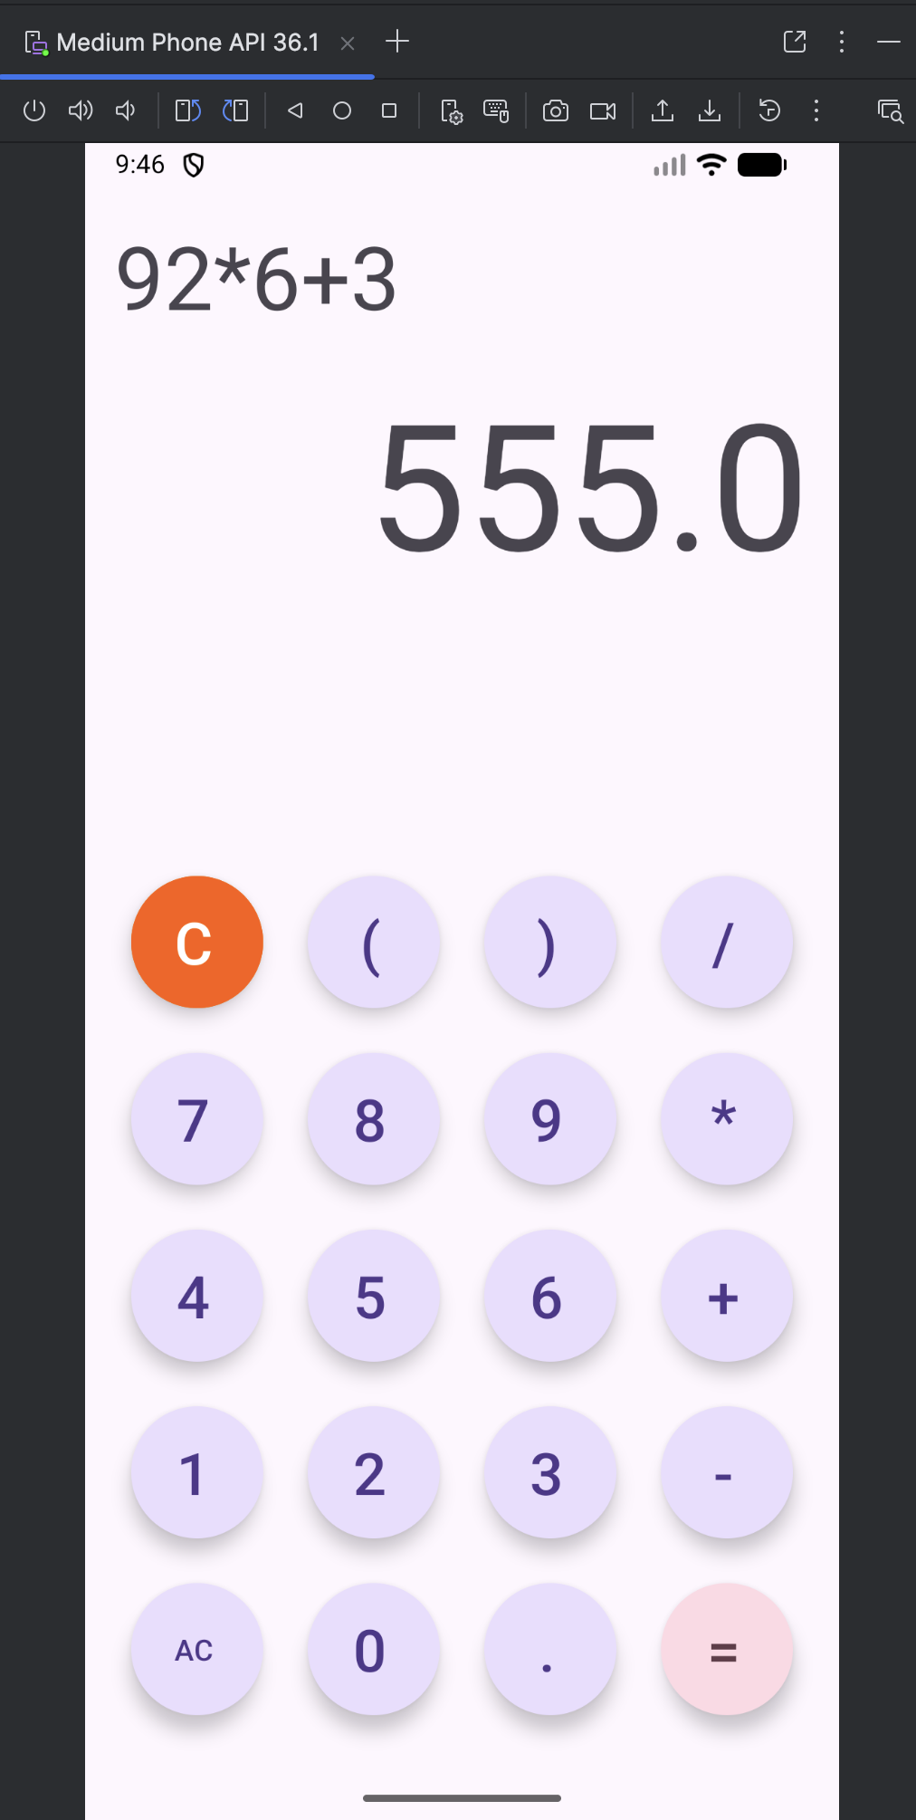

Question3:

Create the following scenario using linear and relative layout concept

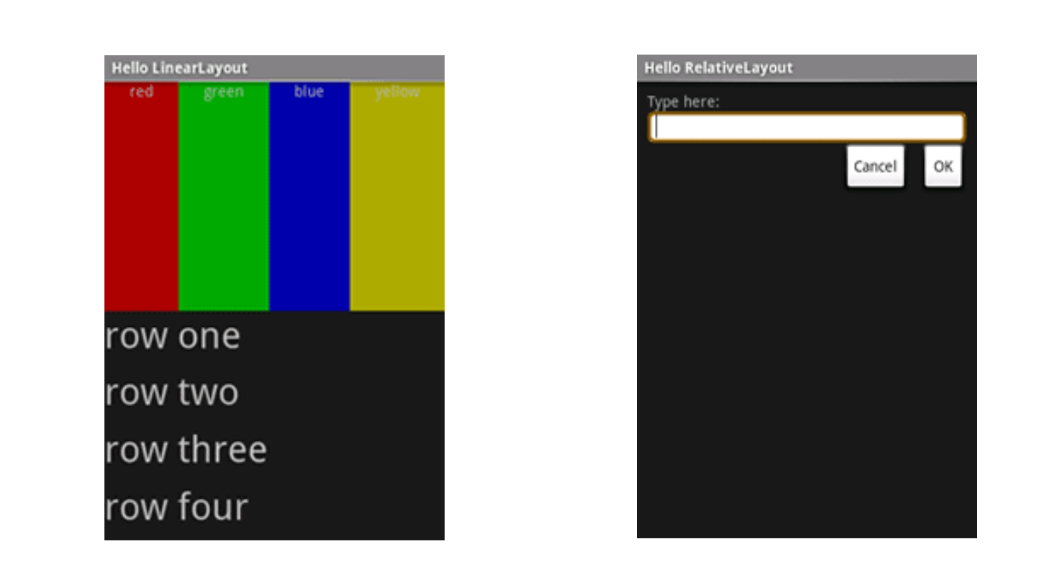

Layout Design Linear

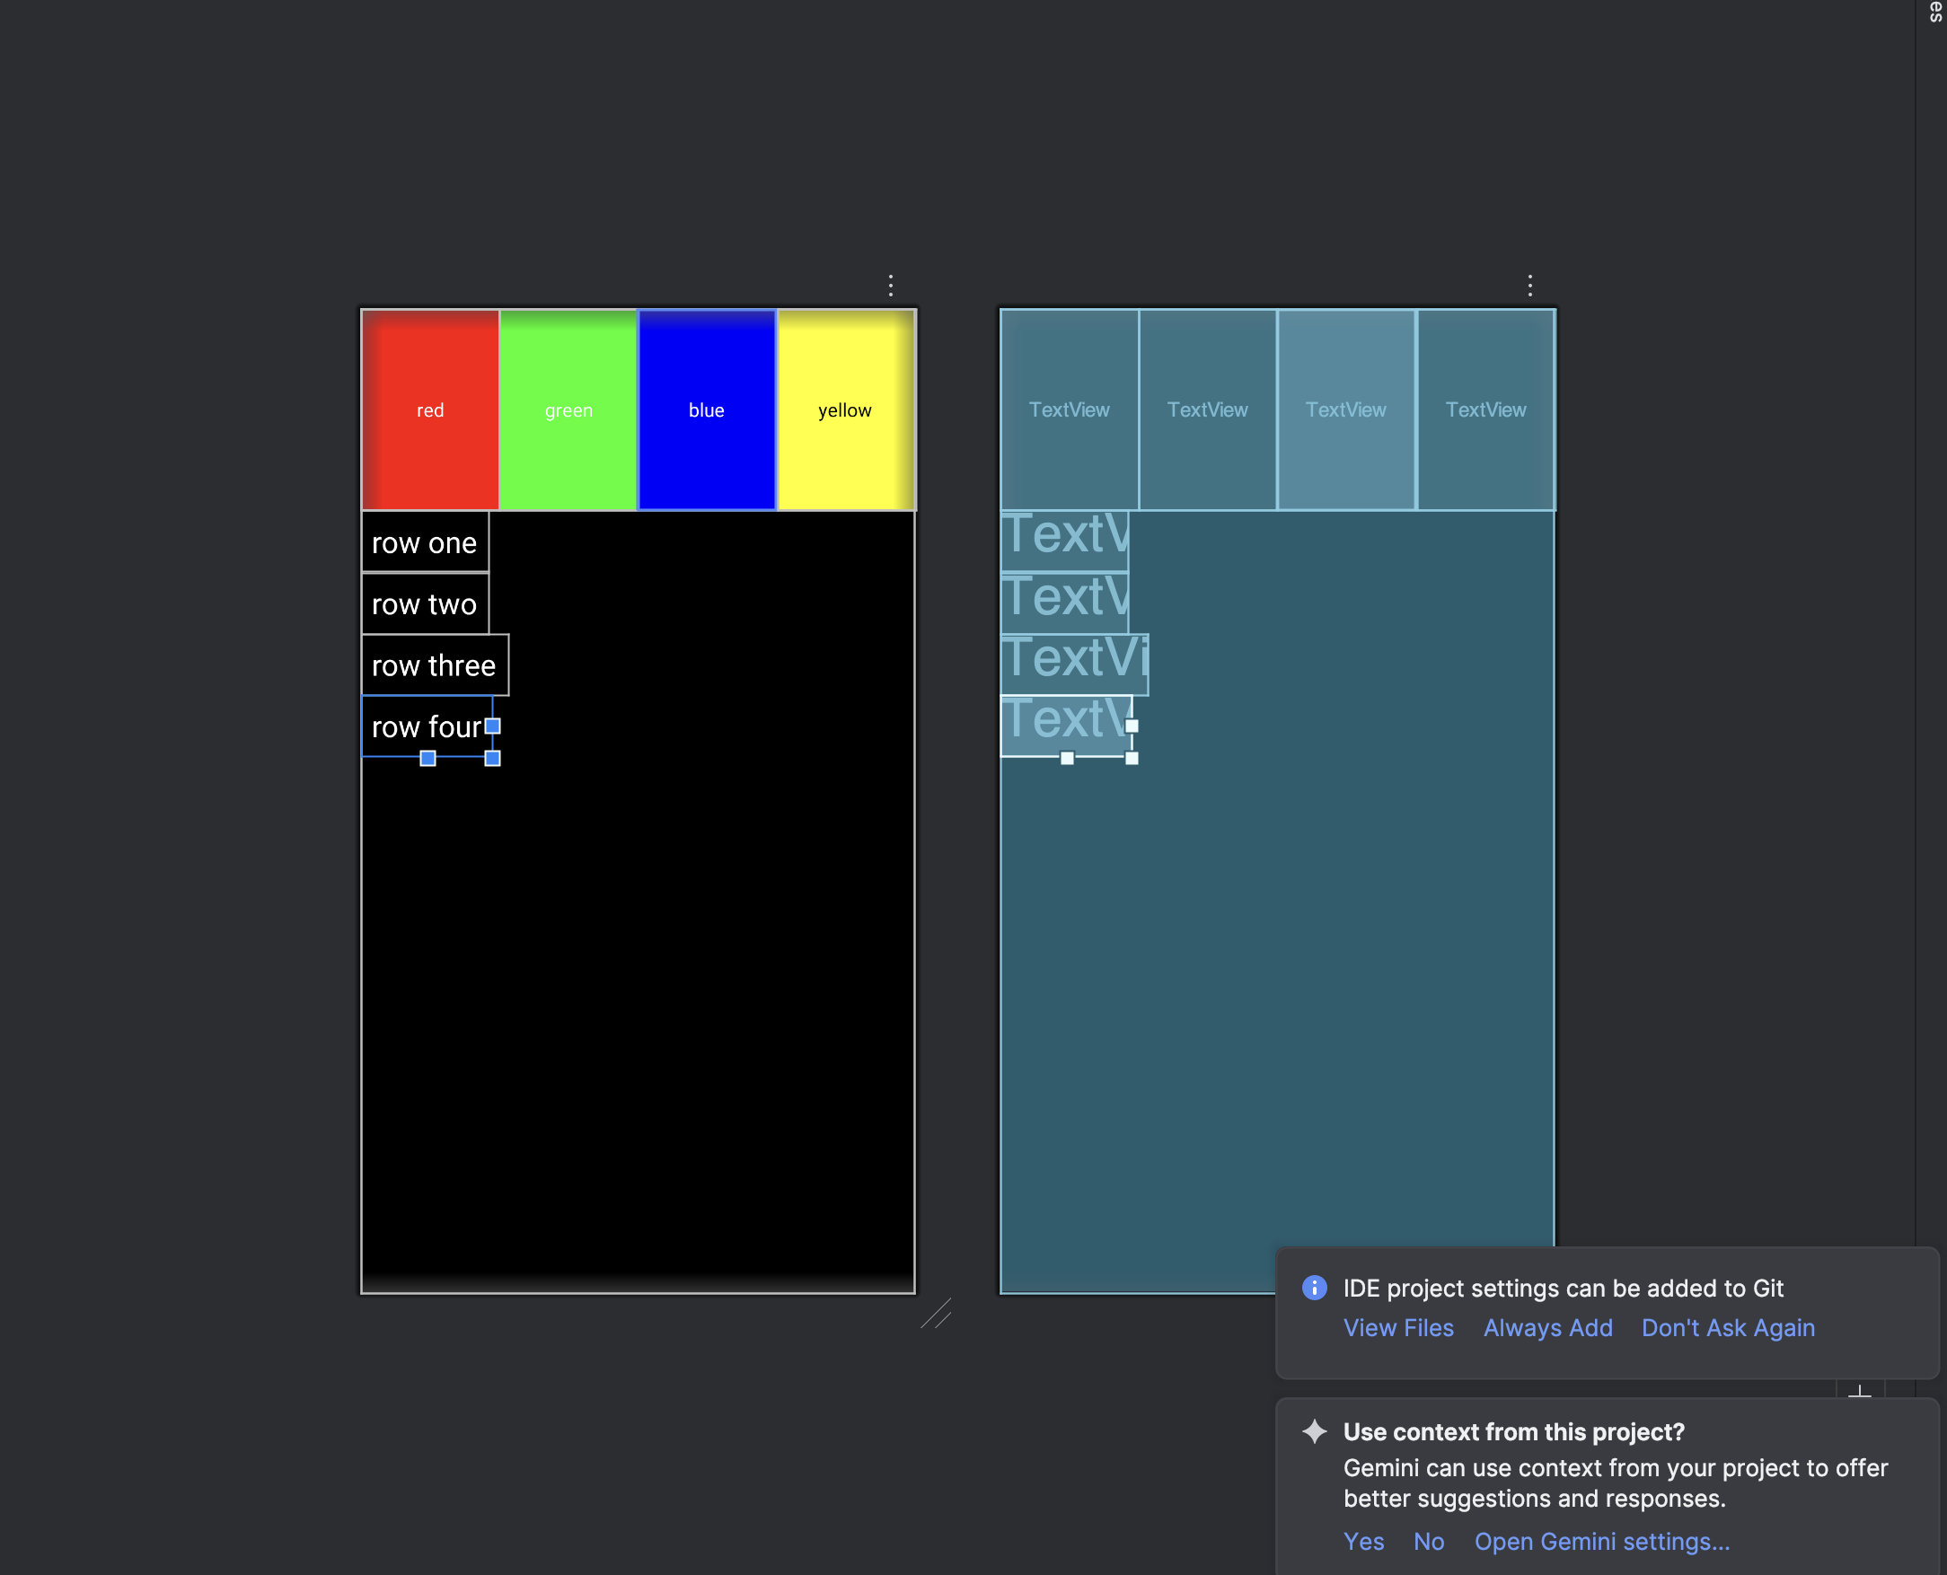

XML for Linear Layout Design

<?xml version="1.0" encoding="utf-8"?>  
<LinearLayout xmlns:android="http://schemas.android.com/apk/res/android"  
 android:layout_width="match_parent"  
 android:layout_height="match_parent"  
 android:orientation="vertical"  
 android:background="#000000">  
  
 <LinearLayout  
 android:layout_width="match_parent"  
 android:layout_height="150dp"  
 android:orientation="horizontal">  
  
 <TextView  
 android:layout_width="0dp"  
 android:layout_height="match_parent"  
 android:layout_weight="1"  
 android:background="#FF0000"  
 android:text="red"  
 android:textColor="#FFFFFF"  
 android:gravity="center"/>  
  
 <TextView  
 android:layout_width="0dp"  
 android:layout_height="match_parent"  
 android:layout_weight="1"  
 android:background="#00FF00"  
 android:text="green"  
 android:textColor="#FFFFFF"  
 android:gravity="center"/>  
  
 <TextView  
 android:layout_width="0dp"  
 android:layout_height="match_parent"  
 android:layout_weight="1"  
 android:background="#0000FF"  
 android:text="blue"  
 android:textColor="#FFFFFF"  
 android:gravity="center"/>  
  
 <TextView  
 android:layout_width="0dp"  
 android:layout_height="match_parent"  
 android:layout_weight="1"  
 android:background="#FFFF00"  
 android:text="yellow"  
 android:textColor="#000000"  
 android:gravity="center"/>  
 </LinearLayout>  
  
 <TextView  
 android:layout_height="wrap_content"  
 android:layout_width="wrap_content"  
 android:text="row one"  
 android:textSize="22sp"  
 android:textColor="#FFFFFF"  
 android:padding="8dp"/>  
  
 <TextView  
 android:layout_height="wrap_content"  
 android:layout_width="wrap_content"  
 android:text="row two"  
 android:textSize="22sp"  
 android:textColor="#FFFFFF"  
 android:padding="8dp"/>  
  
 <TextView  
 android:layout_height="wrap_content"  
 android:layout_width="wrap_content"  
 android:text="row three"  
 android:textSize="22sp"  
 android:textColor="#FFFFFF"  
 android:padding="8dp"/>  
  
 <TextView  
 android:layout_height="wrap_content"  
 android:layout_width="wrap_content"  
 android:text="row four"  
 android:textSize="22sp"  
 android:textColor="#FFFFFF"  
 android:padding="8dp"/>  
  
</LinearLayout>

Layout Design - Relative

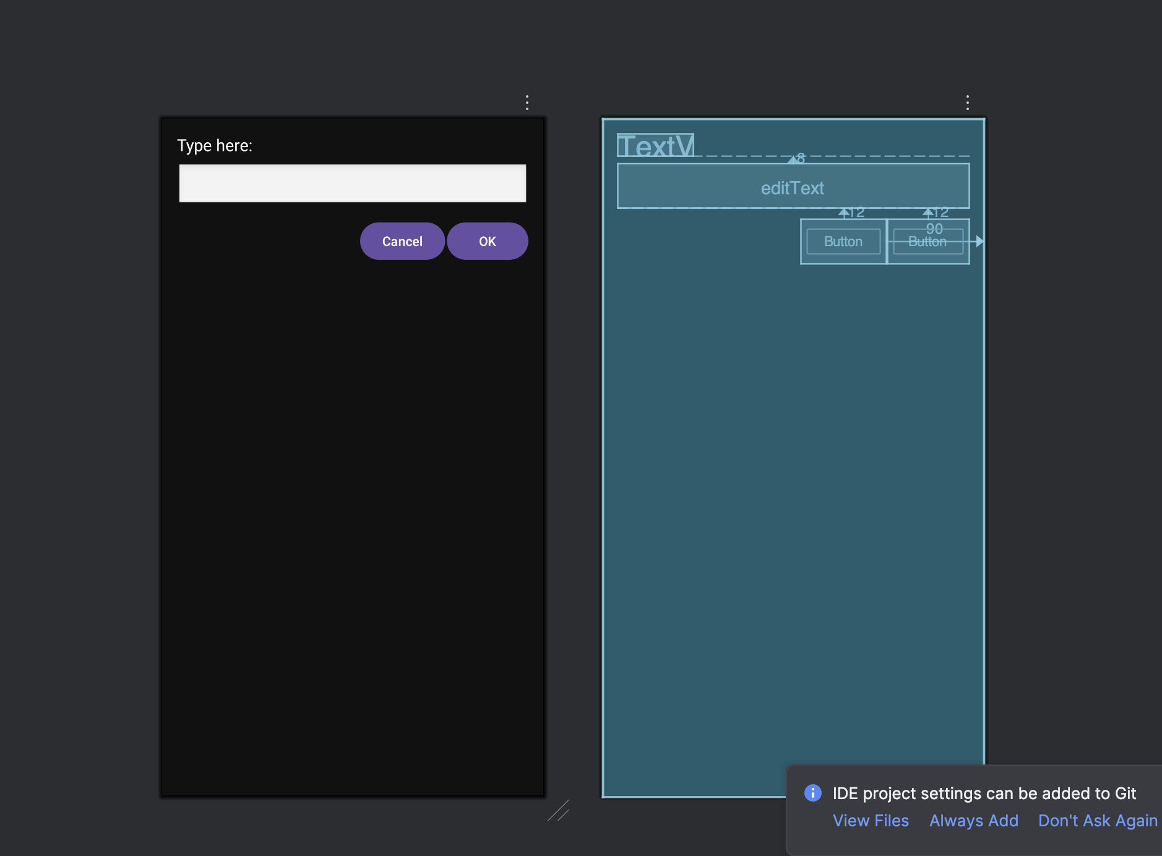

XML for Relative Layout Design

<?xml version="1.0" encoding="utf-8"?>  
<RelativeLayout xmlns:android="http://schemas.android.com/apk/res/android"  
 android:layout_width="match_parent"  
 android:layout_height="match_parent"  
 android:background="#111111"  
 android:padding="16dp">  
  
 <TextView  
 android:id="@+id/tvLabel"  
 android:layout_width="wrap_content"  
 android:layout_height="wrap_content"  
 android:text="Type here:"  
 android:textColor="#FFFFFF"  
 android:textSize="18sp"/>  
  
 <EditText  
 android:id="@+id/editText"  
 android:layout_width="match_parent"  
 android:layout_height="wrap_content"  
 android:layout_below="@id/tvLabel"  
 android:layout_marginTop="8dp"  
 android:background="@android:drawable/edit_text"/>  
  
 <Button  
 android:id="@+id/btnCancel"  
 android:layout_width="wrap_content"  
 android:layout_height="wrap_content"  
 android:text="Cancel"  
 android:layout_below="@id/editText"  
 android:layout_alignParentEnd="true"  
 android:layout_marginTop="12dp"  
 android:layout_marginEnd="90dp"/>  
  
 <Button  
 android:id="@+id/btnOk"  
 android:layout_width="wrap_content"  
 android:layout_height="wrap_content"  
 android:text="OK"  
 android:layout_below="@id/editText"  
 android:layout_alignParentEnd="true"  
 android:layout_marginTop="12dp"/>  
  
</RelativeLayout>

Question4:

Create an app such that when the user click on the given URL typed by the user, it visits the corresponding page.

Layout Design:

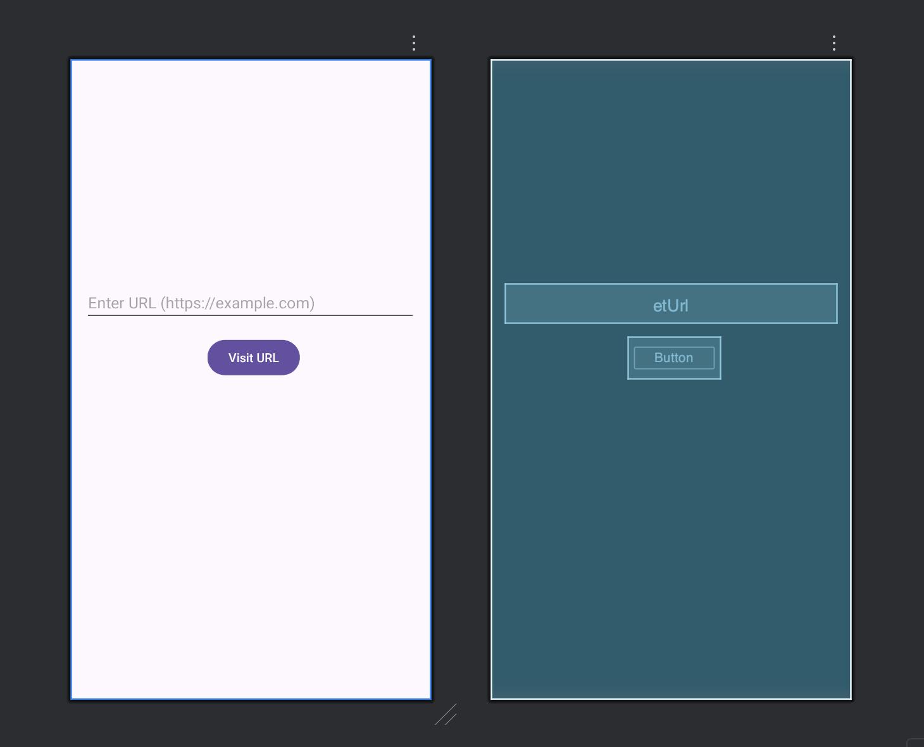

XML for Design:

<?xml version="1.0" encoding="utf-8"?>  
<LinearLayout xmlns:android="http://schemas.android.com/apk/res/android"  
 android:layout_width="match_parent"  
 android:layout_height="match_parent"  
 android:orientation="vertical"  
 android:padding="16dp">  
  
 <EditText  
 android:id="@+id/etUrl"  
 android:layout_marginTop="240dp"  
 android:layout_width="match_parent"  
 android:layout_height="wrap_content"  
 android:hint="Enter URL (https://example.com)"  
 android:inputType="textUri" />  
  
 <Button  
 android:id="@+id/btnVisit"  
 android:layout_width="wrap_content"  
 android:layout_height="wrap_content"  
 android:layout_marginLeft="140dp"  
 android:layout_marginTop="16dp"  
 android:text="Visit URL" />  
  
</LinearLayout>

Java Code:

package com.priyansh.myapplication;  
  
import androidx.appcompat.app.AppCompatActivity;  
  
import android.content.Intent;  
import android.net.Uri;  
import android.os.Bundle;  
import android.view.View;  
import android.widget.Button;  
import android.widget.EditText;  
import android.widget.Toast;  
  
public class MainActivity extends AppCompatActivity {  
  
 EditText etUrl;  
 Button btnVisit;  
  
 @Override  
 protected void onCreate(Bundle savedInstanceState) {  
 super.onCreate(savedInstanceState);  
 setContentView(R.layout.*activity_main*);  
  
 etUrl = findViewById(R.id.*etUrl*);  
 btnVisit = findViewById(R.id.*btnVisit*);  
  
 btnVisit.setOnClickListener(new View.OnClickListener() {  
 @Override  
 public void onClick(View v) {  
  
 String url = etUrl.getText().toString().trim();  
  
 if (url.isEmpty()) {  
 Toast.*makeText*(MainActivity.this,  
 "Please enter a URL", Toast.*LENGTH_SHORT*).show();  
 return;  
 }  
  
 if (!url.startsWith("http://") && !url.startsWith("https://")) {  
 url = "https://" + url;  
 }  
  
 Intent intent = new Intent(Intent.*ACTION_VIEW*);  
 intent.setData(Uri.*parse*(url));  
 startActivity(intent);  
 }  
 });  
 }  
}

Output:

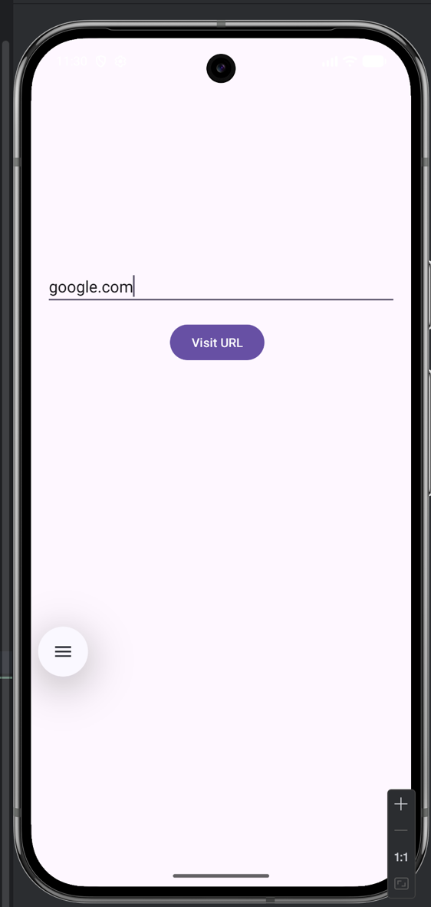 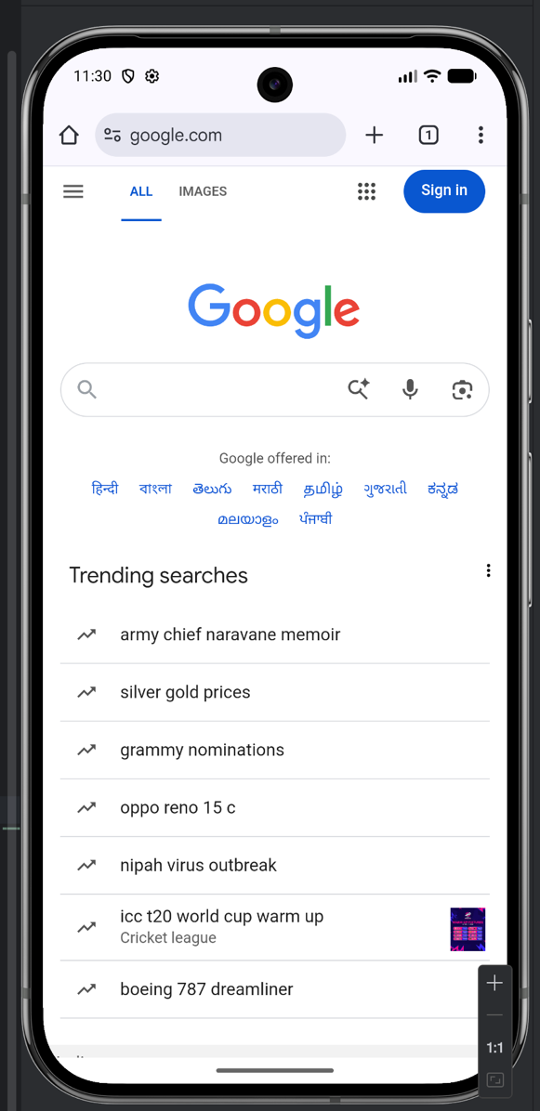

**Lab 2- Activities and Layouts Continued**

Question1:

Using given scenario develop an application to perform following layout operations

* List view
* Grid view
* Tab layout
* Table layout

Layout Designs:

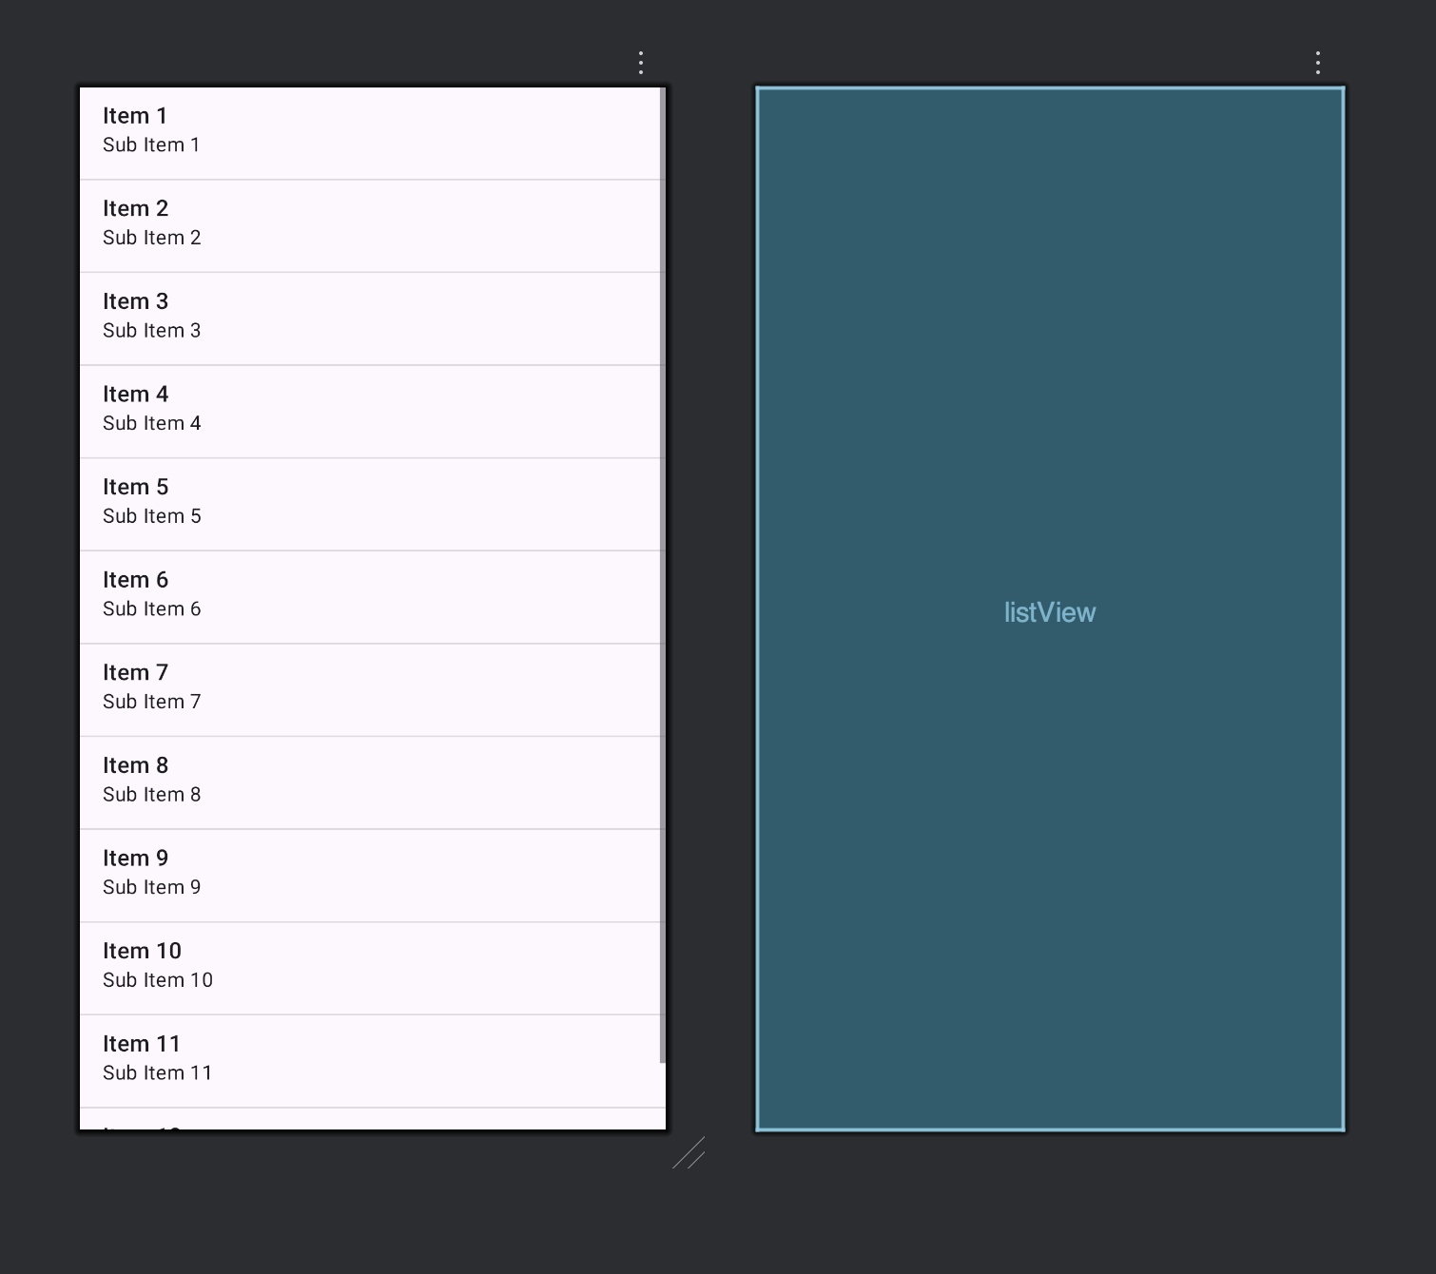

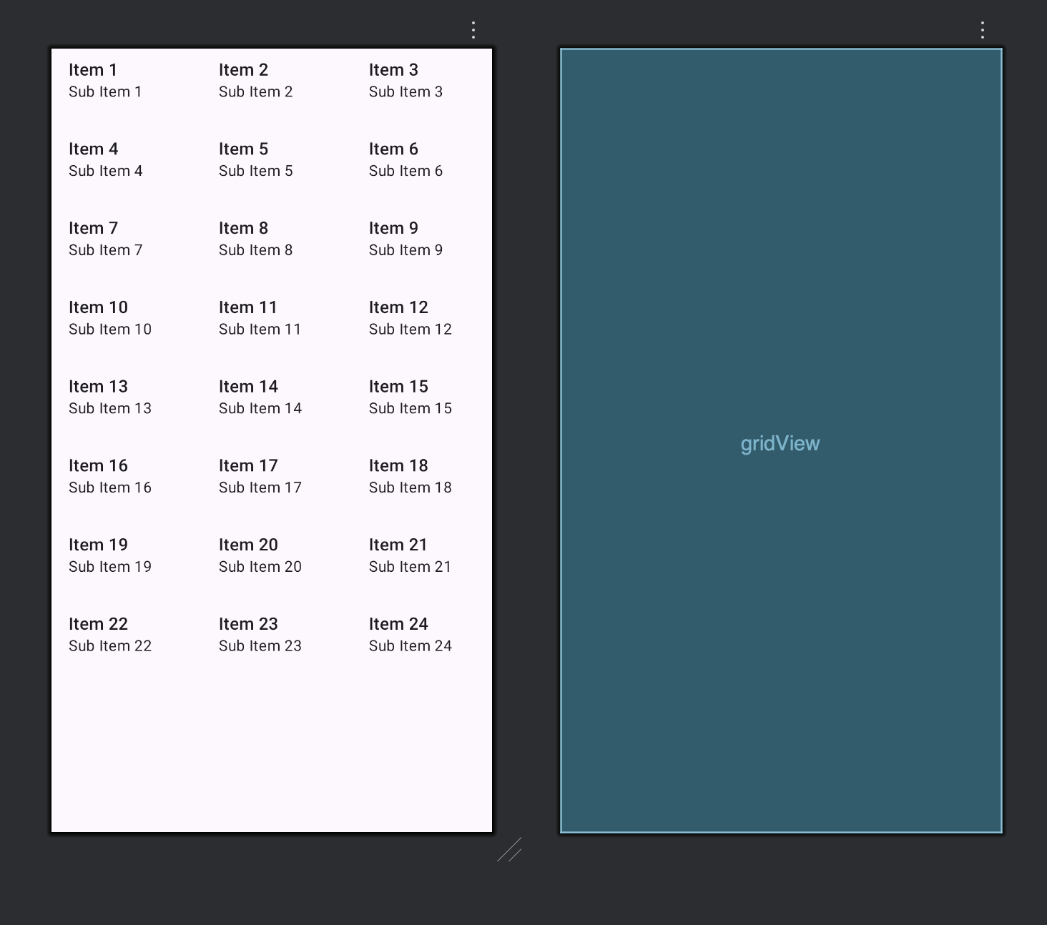

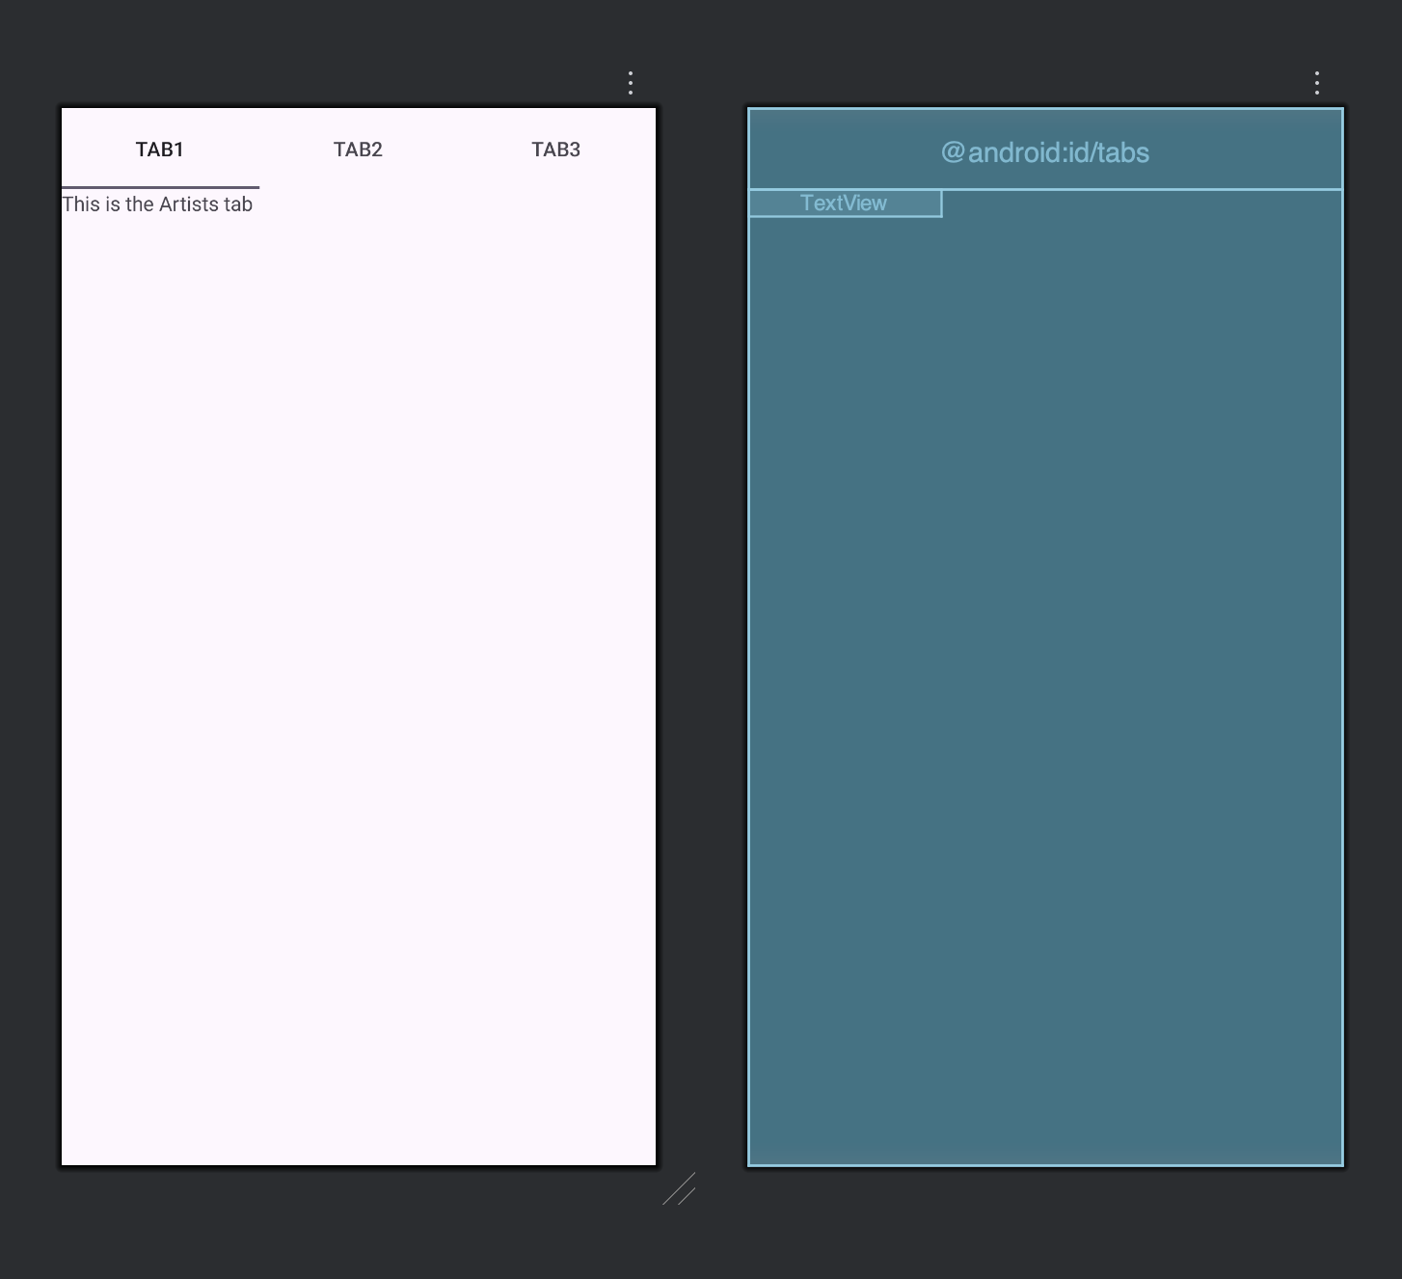

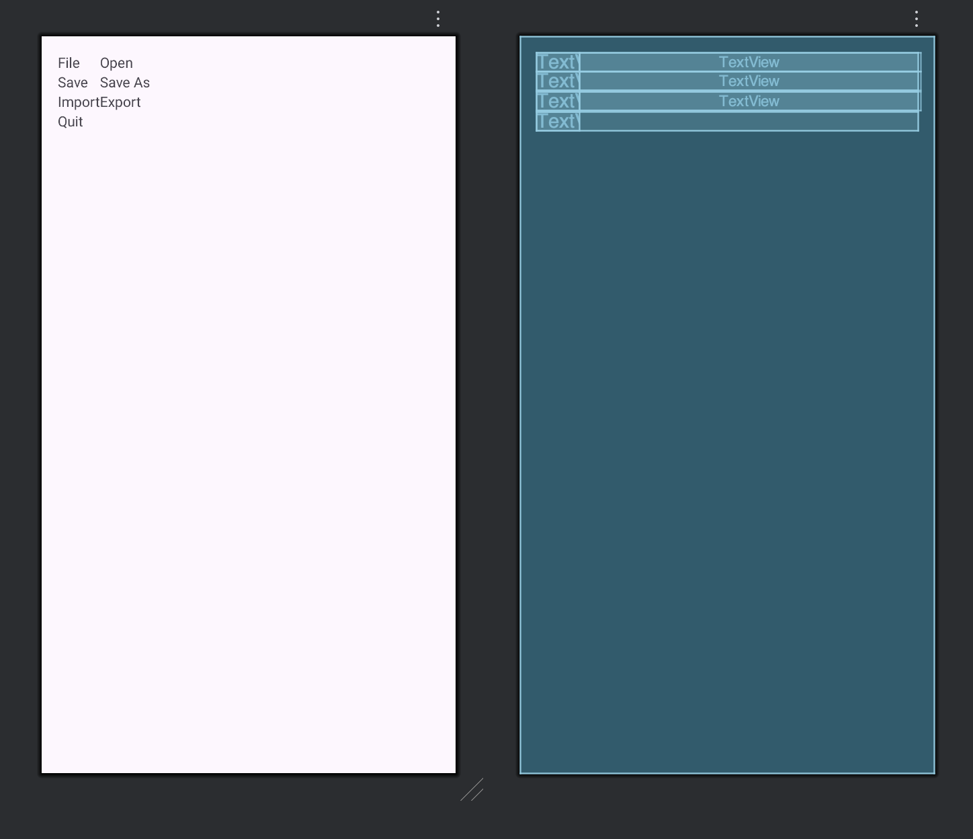

XML Code:

Linear Layout

<ListView xmlns:android="http://schemas.android.com/apk/res/android"  
 android:id="@+id/listView"  
 android:layout_width="match_parent"  
 android:layout_height="match_parent"/>

Grid Layout

<GridView xmlns:android="http://schemas.android.com/apk/res/android"  
 android:id="@+id/gridView"  
 android:layout_width="match_parent"  
 android:layout_height="match_parent"  
 android:numColumns="3"  
 android:verticalSpacing="10dp"  
 android:horizontalSpacing="10dp"  
 android:gravity="center"/>

Tab Layout

<TabHost xmlns:android="http://schemas.android.com/apk/res/android"  
 android:id="@android:id/tabhost"  
 android:layout_width="match_parent"  
 android:layout_height="match_parent">  
  
 <LinearLayout  
 android:layout_width="match_parent"  
 android:layout_height="match_parent"  
 android:orientation="vertical">  
  
 <TabWidget  
 android:id="@android:id/tabs"  
 android:layout_width="match_parent"  
 android:layout_height="wrap_content"/>  
  
 <FrameLayout  
 android:id="@android:id/tabcontent"  
 android:layout_width="match_parent"  
 android:layout_height="match_parent">  
  
 <TextView  
 android:id="@+id/tab1"  
 android:text="This is the Artists tab"  
 android:layout_width="wrap_content"  
 android:layout_height="wrap_content"/>  
  
 <TextView  
 android:id="@+id/tab2"  
 android:text="This is the Albums tab"  
 android:layout_width="wrap_content"  
 android:layout_height="wrap_content"/>  
  
 <TextView  
 android:id="@+id/tab3"  
 android:text="This is the Songs tab"  
 android:layout_width="wrap_content"  
 android:layout_height="wrap_content"/>  
 </FrameLayout>  
  
 </LinearLayout>  
</TabHost>

Table Layout

<TableLayout xmlns:android="http://schemas.android.com/apk/res/android"  
 android:layout_width="match_parent"  
 android:layout_height="match_parent"  
 android:stretchColumns="1"  
 android:padding="16dp">  
  
 <TableRow>  
 <TextView android:text="File"/>  
 <TextView android:text="Open"/>  
 </TableRow>  
  
 <TableRow>  
 <TextView android:text="Save"/>  
 <TextView android:text="Save As"/>  
 </TableRow>  
  
 <TableRow>  
 <TextView android:text="Import"/>  
 <TextView android:text="Export"/>  
 </TableRow>  
  
 <TableRow>  
 <TextView android:text="Quit"/>  
 </TableRow>  
  
</TableLayout>

Java Codes:

Linear

package com.priyansh.question1;  
  
import android.os.Bundle;  
import android.widget.ArrayAdapter;  
import android.widget.ListView;  
import androidx.appcompat.app.AppCompatActivity;  
  
public class MainActivity extends AppCompatActivity {  
  
 String[] countries = {  
 "American Samoa",  
 "El Salvador",  
 "Saint Helena",  
 "Saint Lucia",  
 "Samoa",  
 "San Marino"  
 };  
  
 @Override  
 protected void onCreate(Bundle savedInstanceState) {  
 super.onCreate(savedInstanceState);  
 setContentView(R.layout.*activity_main*);  
  
 ListView listView = findViewById(R.id.*listView*);  
 ArrayAdapter<String> adapter =  
 new ArrayAdapter<>(this,  
 android.R.layout.*simple_list_item_1*,  
 countries);  
  
 listView.setAdapter(adapter);  
 }  
}

Grid

package com.priyansh.question1;  
  
import android.os.Bundle;  
import android.widget.ArrayAdapter;  
  
import androidx.appcompat.app.AppCompatActivity;  
  
public class GridView extends AppCompatActivity {  
  
 String[] items = {  
 "One", "Two", "Three",  
 "Four", "Five", "Six",  
 "Seven", "Eight", "Nine"  
 };  
  
 @Override  
 protected void onCreate(Bundle savedInstanceState) {  
 super.onCreate(savedInstanceState);  
 setContentView(R.layout.*activity_grid_view*);  
  
 android.widget.GridView gridView = findViewById(R.id.*gridView*);  
 ArrayAdapter<String> adapter =  
 new ArrayAdapter<>(this,  
 android.R.layout.*simple_list_item_1*,  
 items);  
  
 gridView.setAdapter(adapter);  
 }  
}

Tab

package com.priyansh.question1;  
  
import android.os.Bundle;  
import android.widget.TabHost;  
import androidx.appcompat.app.AppCompatActivity;  
  
public class TabLayout extends AppCompatActivity {  
  
 @Override  
 protected void onCreate(Bundle savedInstanceState) {  
 super.onCreate(savedInstanceState);  
 setContentView(R.layout.*activity_tab_layout*);  
  
 TabHost tabHost = findViewById(android.R.id.*tabhost*);  
 tabHost.setup();  
  
 TabHost.TabSpec spec;  
  
 spec = tabHost.newTabSpec("Artists");  
 spec.setContent(R.id.*tab1*);  
 spec.setIndicator("Artists");  
 tabHost.addTab(spec);  
  
 spec = tabHost.newTabSpec("Albums");  
 spec.setContent(R.id.*tab2*);  
 spec.setIndicator("Albums");  
 tabHost.addTab(spec);  
  
 spec = tabHost.newTabSpec("Songs");  
 spec.setContent(R.id.*tab3*);  
 spec.setIndicator("Songs");  
 tabHost.addTab(spec);  
 }  
}

Output Example:

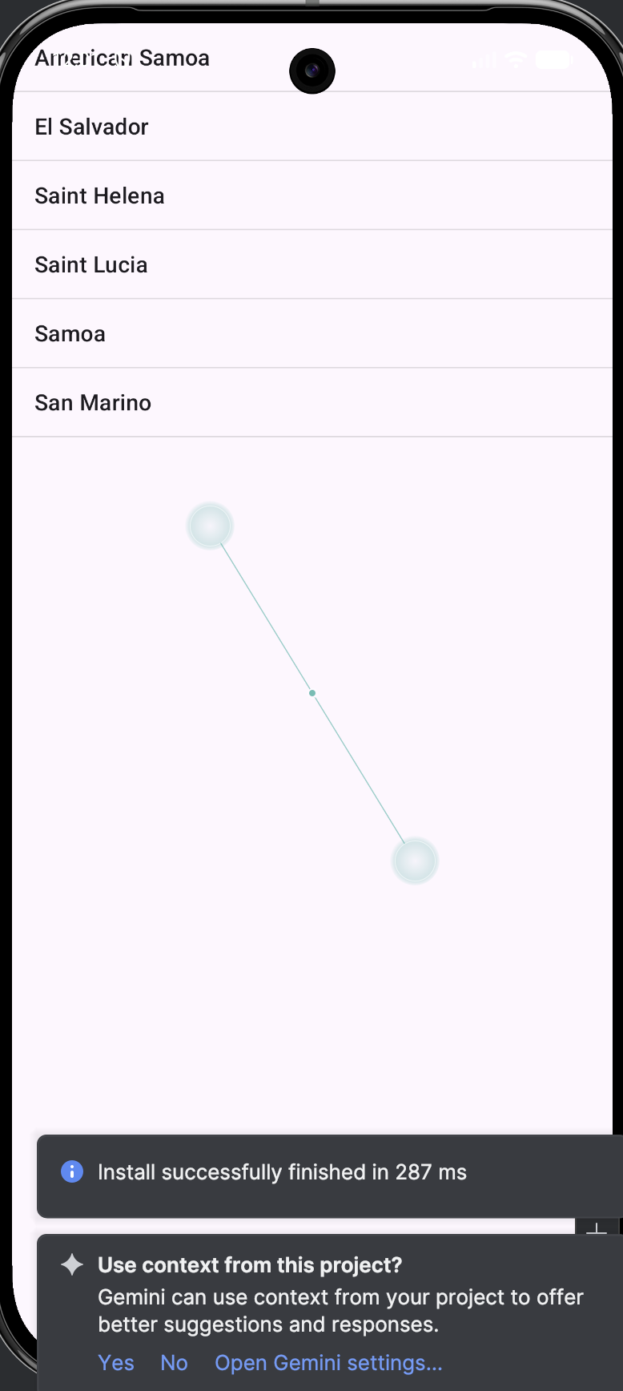

Question 2:

Write a program to list different sports, and when a sport is selected, display a message showing the selected sport.

Layout Design:

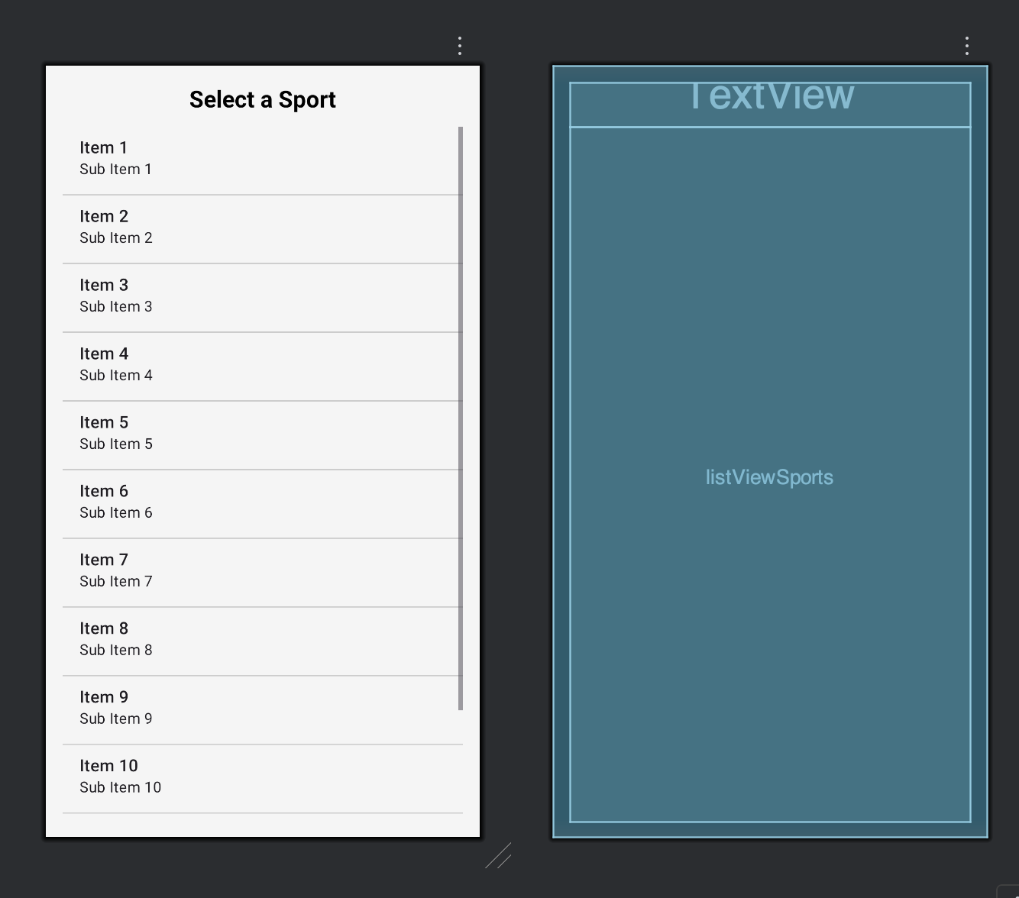

XML:

<?xml version="1.0" encoding="utf-8"?>  
<LinearLayout xmlns:android="http://schemas.android.com/apk/res/android"  
 android:layout_width="match_parent"  
 android:layout_height="match_parent"  
 android:orientation="vertical"  
 android:padding="16dp"  
 android:background="#F5F5F5">  
  
 <TextView  
 android:layout_width="match_parent"  
 android:layout_height="wrap_content"  
 android:text="Select a Sport"  
 android:textSize="22sp"  
 android:textStyle="bold"  
 android:textColor="#000000"  
 android:gravity="center"  
 android:paddingBottom="12dp"/>  
  
 <ListView  
 android:id="@+id/listViewSports"  
 android:layout_width="match_parent"  
 android:layout_height="match_parent"  
 android:divider="#CCCCCC"  
 android:dividerHeight="1dp"/>  
</LinearLayout>

Java:

package com.priyansh.question2;  
  
import androidx.appcompat.app.AppCompatActivity;  
import android.os.Bundle;  
import android.view.View;  
import android.widget.AdapterView;  
import android.widget.ArrayAdapter;  
import android.widget.ListView;  
import android.widget.Toast;  
  
public class MainActivity extends AppCompatActivity {  
  
 ListView listView;  
 String[] sports = {  
 "Cricket",  
 "Football",  
 "Basketball",  
 "Tennis",  
 "Hockey",  
 "Badminton"  
 };  
  
 @Override  
 protected void onCreate(Bundle savedInstanceState) {  
 super.onCreate(savedInstanceState);  
 setContentView(R.layout.*activity_main*);  
  
 listView = findViewById(R.id.*listViewSports*);  
  
 ArrayAdapter<String> adapter =  
 new ArrayAdapter<>(this,  
 android.R.layout.*simple_list_item_1*,  
 sports);  
  
 listView.setAdapter(adapter);  
  
 listView.setOnItemClickListener(new AdapterView.OnItemClickListener() {  
 @Override  
 public void onItemClick(AdapterView<?> parent,  
 View view,  
 int position,  
 long id) {  
  
 String selectedSport = sports[position];  
 Toast.*makeText*(MainActivity.this,  
 "Selected sport: " + selectedSport,  
 Toast.*LENGTH_SHORT*).show();  
 }  
 });  
 }  
}

Output:

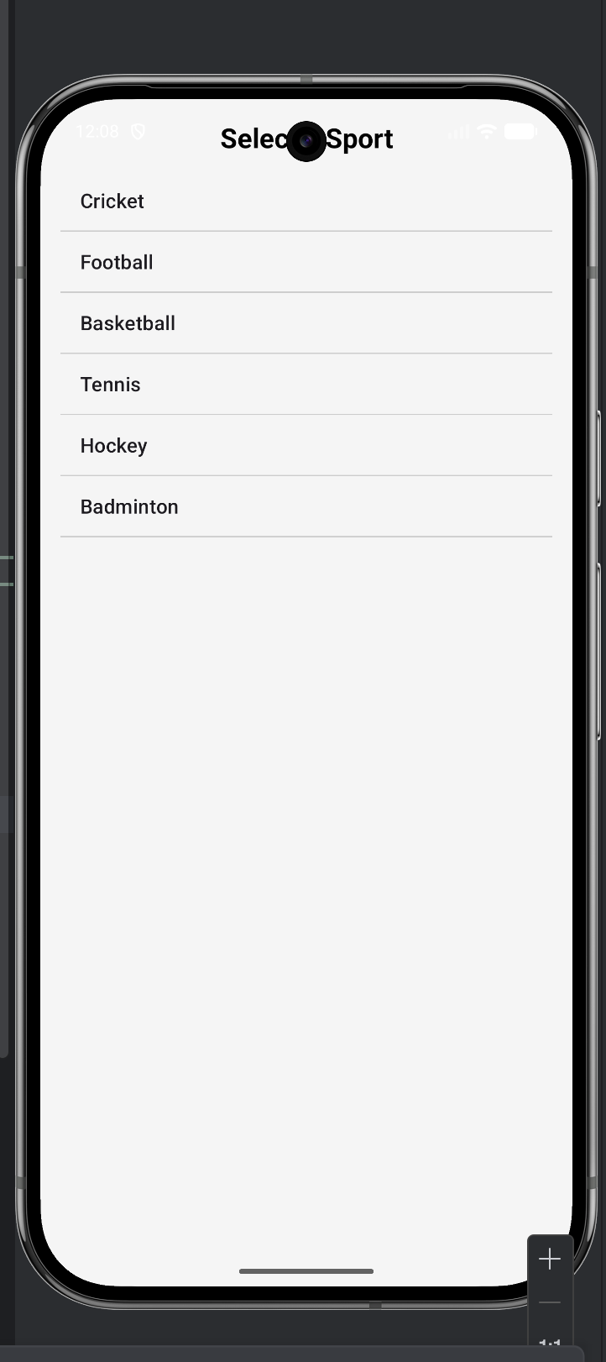 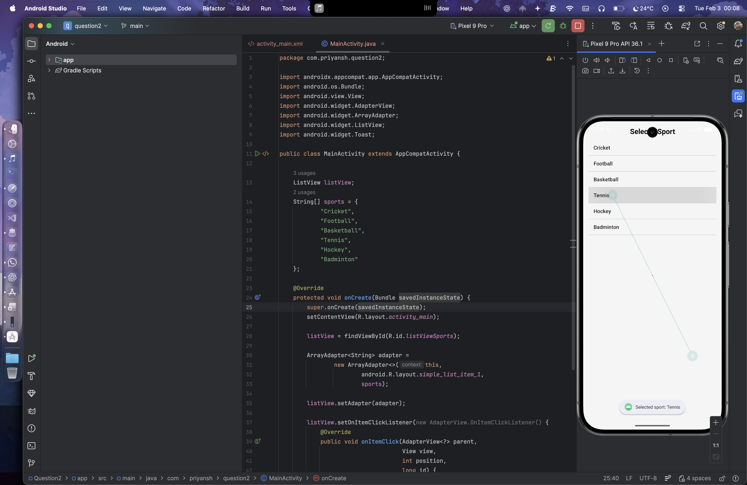

Question 3:

Design an news application and Implement the navigation between the sections like Top Stories, Sports, and Entertainment using tab layout

Layout Designs:

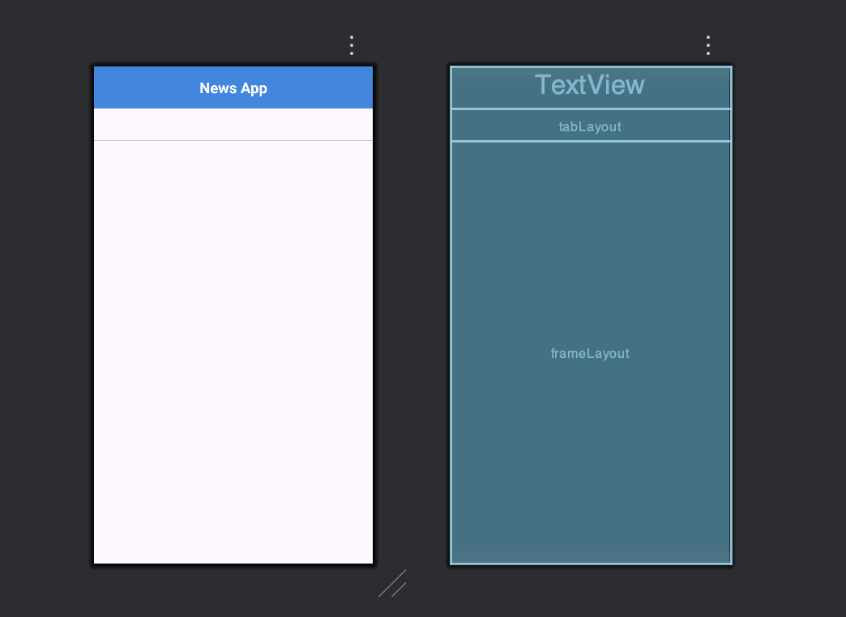

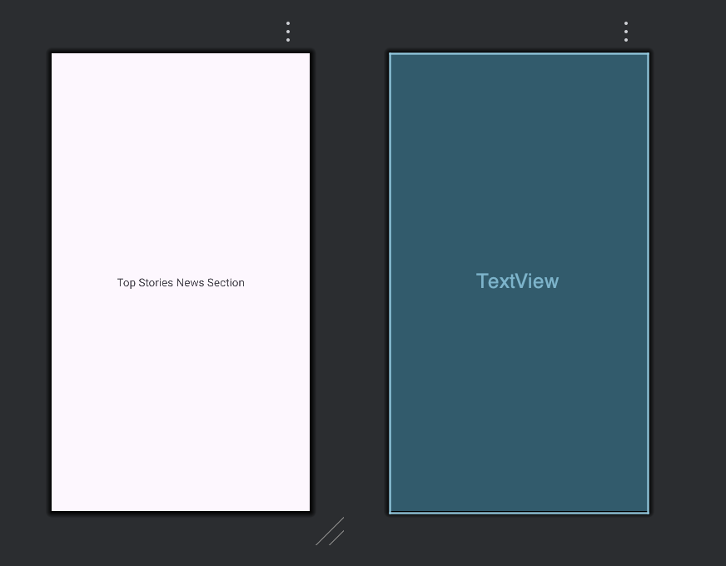

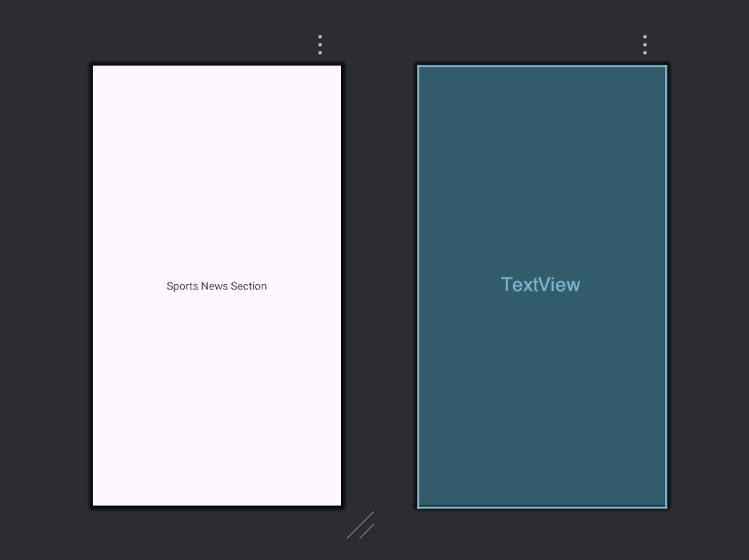

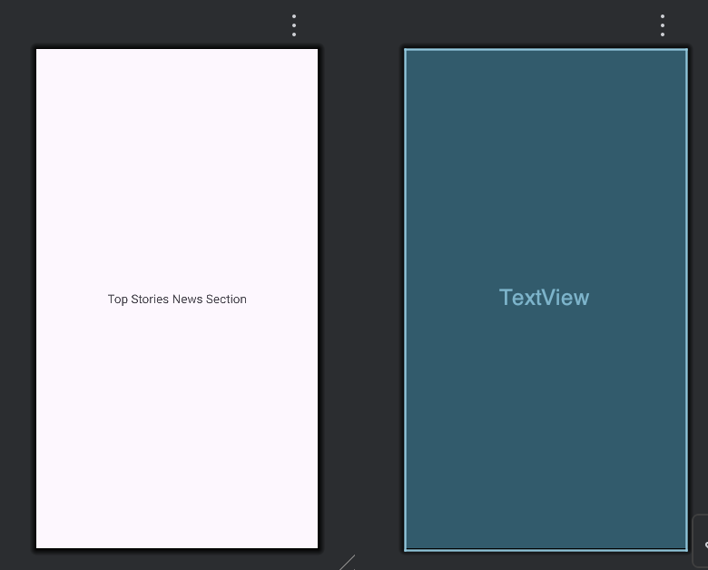

XML for Designs

activity_main.xml

<?xml version="1.0" encoding="utf-8"?>  
<LinearLayout xmlns:android="http://schemas.android.com/apk/res/android"  
 xmlns:app="http://schemas.android.com/apk/res-auto"  
 android:layout_width="match_parent"  
 android:layout_height="match_parent"  
 android:orientation="vertical">  
  
 <TextView  
 android:layout_width="match_parent"  
 android:layout_height="wrap_content"  
 android:text="News App"  
 android:textSize="22sp"  
 android:textStyle="bold"  
 android:padding="16dp"  
 android:gravity="center"  
 android:background="#1E88E5"  
 android:textColor="#FFFFFF"/>  
  
 <com.google.android.material.tabs.TabLayout  
 android:id="@+id/tabLayout"  
 android:layout_width="match_parent"  
 android:layout_height="wrap_content"  
 app:tabIndicatorColor="#1E88E5"  
 app:tabSelectedTextColor="#1E88E5"  
 app:tabTextColor="#666666"  
 app:tabMode="fixed"  
 app:tabGravity="fill"/>  
  
 <!-- Content Area -->  
 <FrameLayout  
 android:id="@+id/frameLayout"  
 android:layout_width="match_parent"  
 android:layout_height="match_parent"  
 android:padding="16dp"/>  
  
</LinearLayout>

top_stories.xml

<TextView xmlns:android="http://schemas.android.com/apk/res/android"  
 android:layout_width="match_parent"  
 android:layout_height="match_parent"  
 android:text="Top Stories News Section"  
 android:textSize="18sp"  
 android:gravity="center"/>

sports.xml

<TextView xmlns:android="http://schemas.android.com/apk/res/android"  
 android:layout_width="match_parent"  
 android:layout_height="match_parent"  
 android:text="Sports News Section"  
 android:textSize="18sp"  
 android:gravity="center"/>

entertainment.xml

<TextView xmlns:android="http://schemas.android.com/apk/res/android"  
 android:layout_width="match_parent"  
 android:layout_height="match_parent"  
 android:text="Top Stories News Section"  
 android:textSize="18sp"  
 android:gravity="center"/>

Java Code:

package com.priyansh.question3;  
  
import android.os.Bundle;  
import android.view.LayoutInflater;  
import android.view.View;  
import android.widget.FrameLayout;  
  
import androidx.appcompat.app.AppCompatActivity;  
  
import com.google.android.material.tabs.TabLayout;  
  
public class MainActivity extends AppCompatActivity {  
  
 TabLayout tabLayout;  
 FrameLayout frameLayout;  
  
 @Override  
 protected void onCreate(Bundle savedInstanceState) {  
 super.onCreate(savedInstanceState);  
 setContentView(R.layout.*activity_main*);  
  
 tabLayout = findViewById(R.id.*tabLayout*);  
 frameLayout = findViewById(R.id.*frameLayout*);  
  
 tabLayout.addTab(tabLayout.newTab().setText("Top Stories"));  
 tabLayout.addTab(tabLayout.newTab().setText("Sports"));  
 tabLayout.addTab(tabLayout.newTab().setText("Entertainment"));  
  
 loadLayout(R.layout.*top_stories*);  
  
 tabLayout.addOnTabSelectedListener(new TabLayout.OnTabSelectedListener() {  
 @Override  
 public void onTabSelected(TabLayout.Tab tab) {  
 switch (tab.getPosition()) {  
 case 0:  
 loadLayout(R.layout.*top_stories*);  
 break;  
 case 1:  
 loadLayout(R.layout.*sports*);  
 break;  
 case 2:  
 loadLayout(R.layout.*entertainment*);  
 break;  
 }  
 }  
  
 @Override public void onTabUnselected(TabLayout.Tab tab) {}  
 @Override public void onTabReselected(TabLayout.Tab tab) {}  
 });  
 }  
  
 private void loadLayout(int layoutId) {  
 frameLayout.removeAllViews();  
 View view = LayoutInflater.*from*(this).inflate(layoutId, frameLayout, false);  
 frameLayout.addView(view);  
 }  
}

Output:

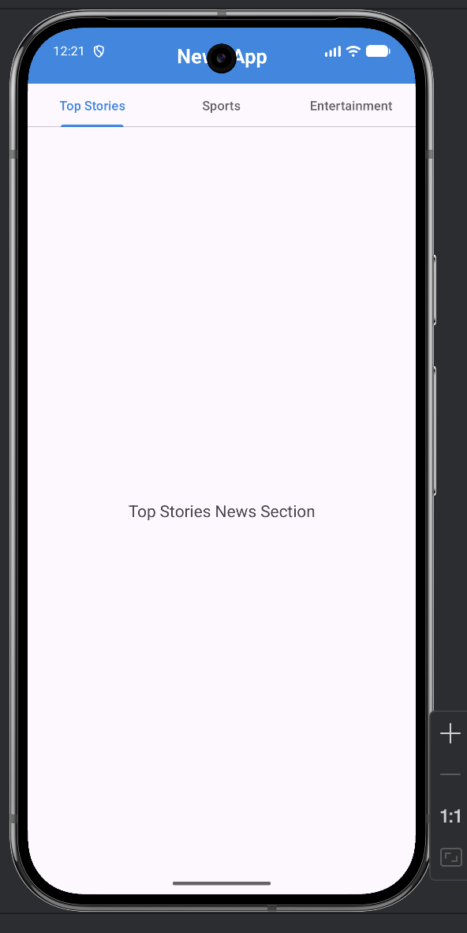 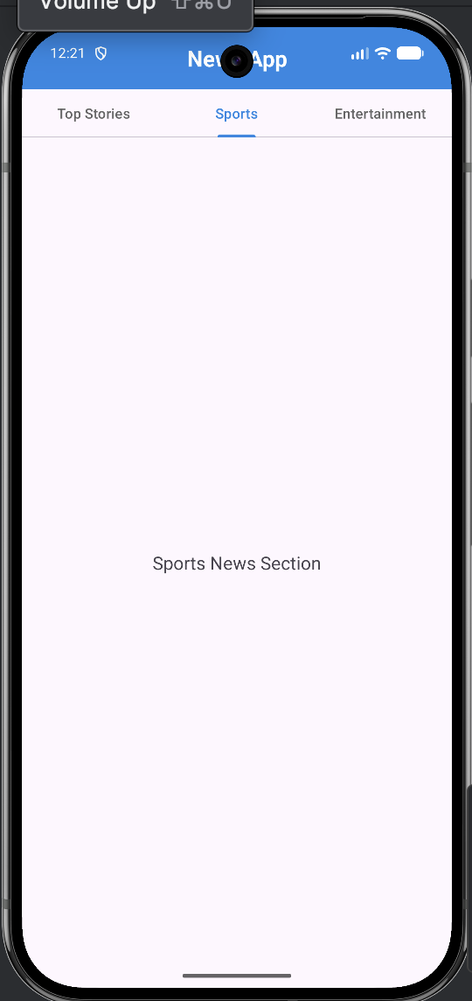

**Lab 4- Input Controls in Android**

Question 1:

Develop a “Test app” that includes a layout with a button and a ToggleButton. When each button is clicked a custom Toast message should be displayed with different images as their content.

Layout Design:

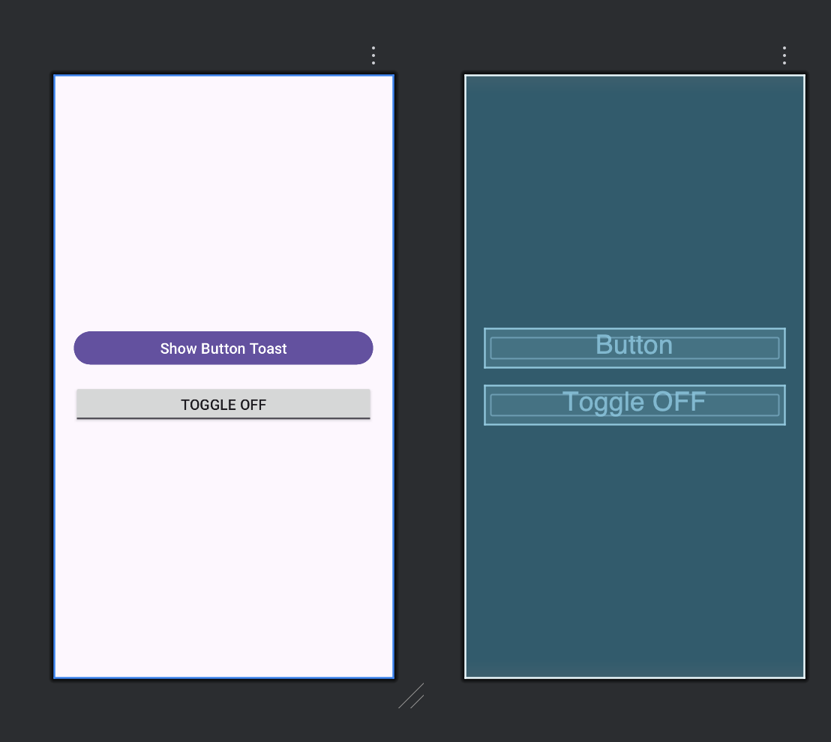

XML for activity_main.xml

<?xml version="1.0" encoding="utf-8"?>  
<LinearLayout xmlns:android="http://schemas.android.com/apk/res/android"  
 android:layout_width="match_parent"  
 android:layout_height="match_parent"  
 android:orientation="vertical"  
 android:gravity="center"  
 android:padding="24dp">  
  
 <Button  
 android:id="@+id/btnShow"  
 android:layout_width="match_parent"  
 android:layout_height="wrap_content"  
 android:text="Show Button Toast"  
 android:textSize="18sp"  
 android:layout_marginBottom="20dp"/>  
  
 <ToggleButton  
 android:id="@+id/toggleBtn"  
 android:layout_width="match_parent"  
 android:layout_height="wrap_content"  
 android:textOn="Toggle ON"  
 android:textOff="Toggle OFF"  
 android:textSize="18sp"/>  
  
</LinearLayout>

XML for custom_toast.xml

<?xml version="1.0" encoding="utf-8"?>  
<LinearLayout xmlns:android="http://schemas.android.com/apk/res/android"  
 android:layout_width="wrap_content"  
 android:layout_height="wrap_content"  
 android:orientation="horizontal"  
 android:padding="12dp"  
 android:background="#CC000000"  
 android:gravity="center">  
  
 <ImageView  
 android:id="@+id/toastImage"  
 android:layout_width="40dp"  
 android:layout_height="40dp"  
 android:layout_marginEnd="10dp"/>  
  
 <TextView  
 android:id="@+id/toastText"  
 android:layout_width="wrap_content"  
 android:layout_height="wrap_content"  
 android:textColor="#FFFFFF"  
 android:textSize="16sp"/>  
  
</LinearLayout>

Java Code:

public class MainActivity extends AppCompatActivity {  
  
 Button btnShow;  
 ToggleButton toggleBtn;  
  
 @Override  
 protected void onCreate(Bundle savedInstanceState) {  
 super.onCreate(savedInstanceState);  
 setContentView(R.layout.*activity_main*);  
  
 btnShow = findViewById(R.id.*btnShow*);  
 toggleBtn = findViewById(R.id.*toggleBtn*);  
  
 btnShow.setOnClickListener(v ->  
 showCustomToast("Button Clicked!", R.drawable.*button_img*)  
 );  
  
 toggleBtn.setOnClickListener(v -> {  
 if (toggleBtn.isChecked()) {  
 showCustomToast("Toggle is ON", R.drawable.*toggle_on*);  
 } else {  
 showCustomToast("Toggle is OFF", R.drawable.*toggle_off*);  
 }  
 });  
 }  
  
 private void showCustomToast(String message, int imageRes) {  
 LayoutInflater inflater = getLayoutInflater();  
 View toastView = inflater.inflate(R.layout.*custom_toast*, null);  
  
 ImageView image = toastView.findViewById(R.id.*toastImage*);  
 TextView text = toastView.findViewById(R.id.*toastText*);  
  
 image.setImageResource(imageRes);  
 text.setText(message);  
  
 Toast toast = new Toast(getApplicationContext());  
 toast.setDuration(Toast.*LENGTH_SHORT*);  
 toast.setView(toastView);  
 toast.show();  
 }  
}

Images are added to the drawable folder:  
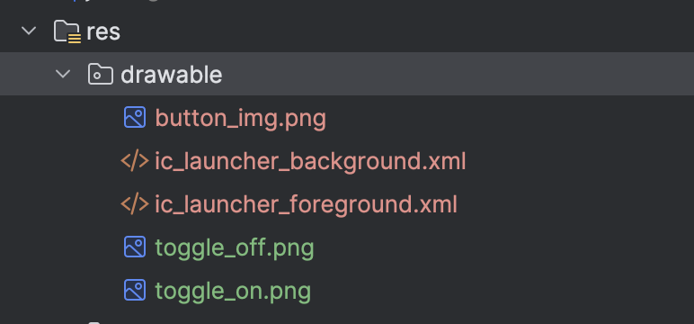

Output:

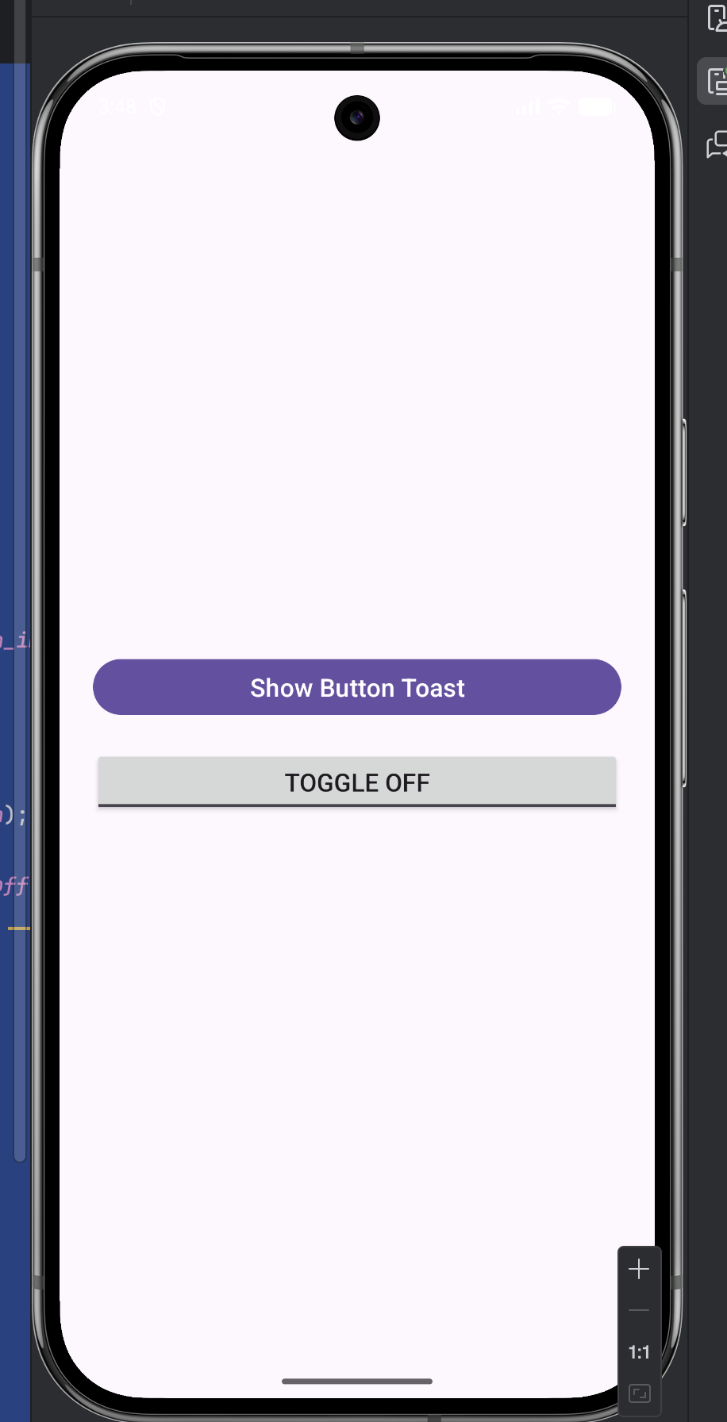 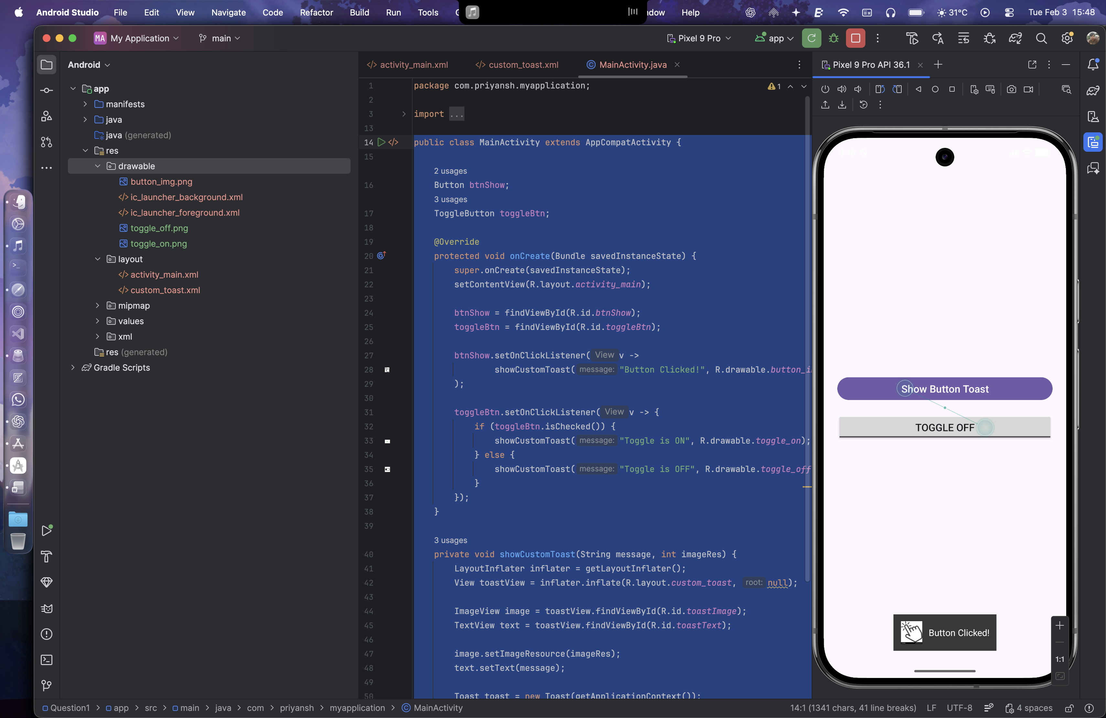 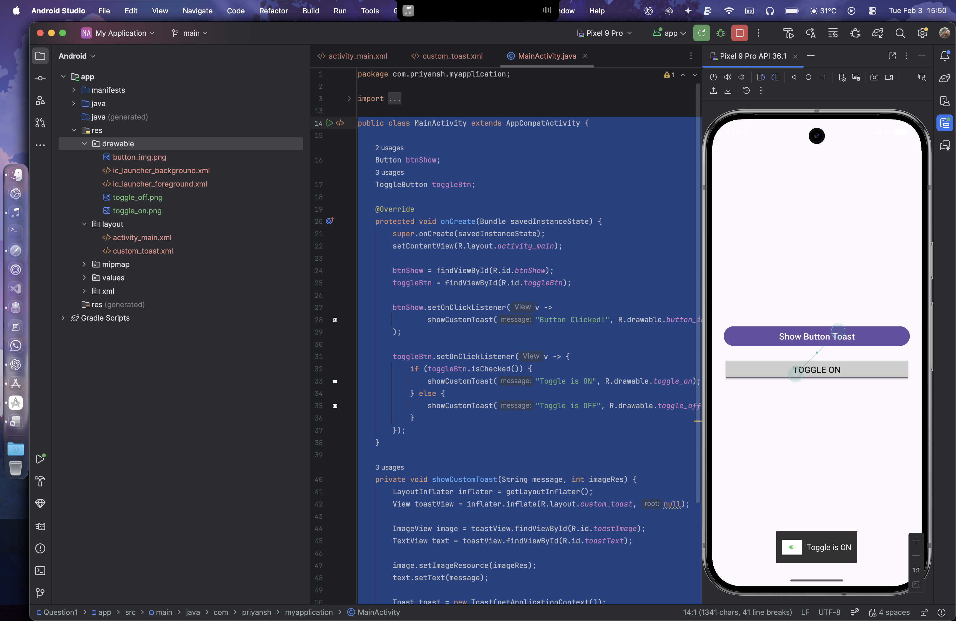 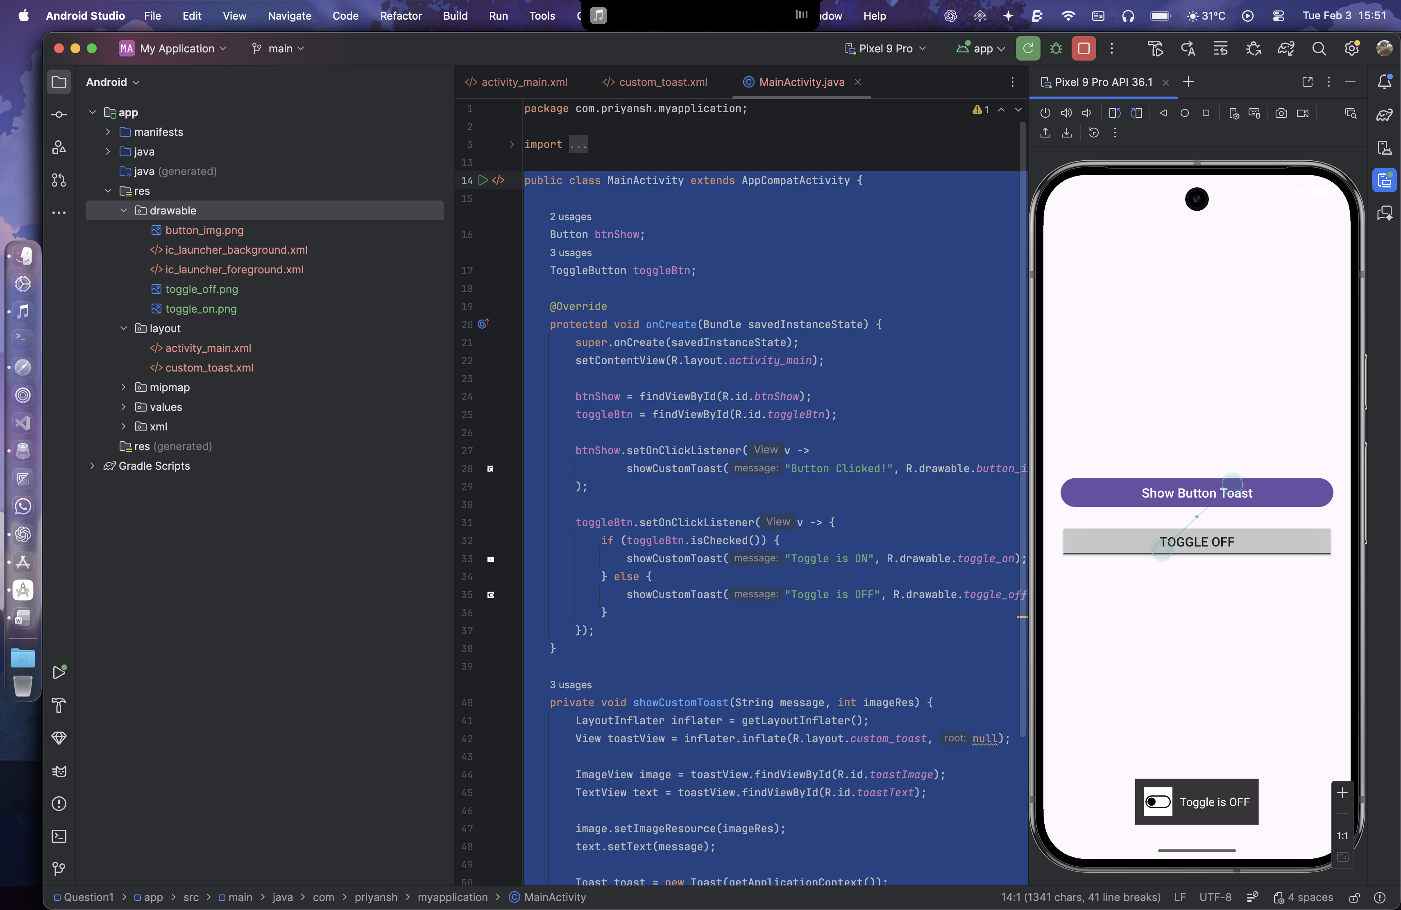

Question 2:

Create an app that contains a view with multiple buttons, each labeled with different Android versions. When a button is clicked, a Toast message should appear, displaying the corresponding Android version's name along with its associated icon.

Layout Design:

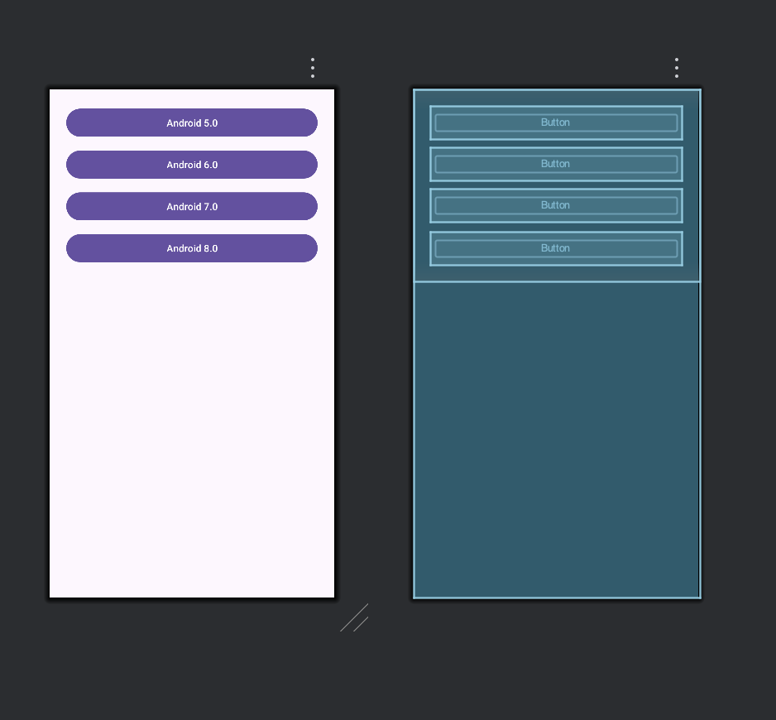

XML for activity_mail.xml

<?xml version="1.0" encoding="utf-8"?>  
<ScrollView xmlns:android="http://schemas.android.com/apk/res/android"  
 android:layout_width="match_parent"  
 android:layout_height="match_parent">  
  
 <LinearLayout  
 android:layout_width="match_parent"  
 android:layout_height="wrap_content"  
 android:orientation="vertical"  
 android:gravity="center"  
 android:padding="24dp">  
  
 <Button  
 android:id="@+id/btnLollipop"  
 android:layout_width="match_parent"  
 android:layout_height="wrap_content"  
 android:text="Android 5.0"  
 android:layout_marginBottom="12dp"/>  
  
 <Button  
 android:id="@+id/btnMarshmallow"  
 android:layout_width="match_parent"  
 android:layout_height="wrap_content"  
 android:text="Android 6.0"  
 android:layout_marginBottom="12dp"/>  
  
 <Button  
 android:id="@+id/btnNougat"  
 android:layout_width="match_parent"  
 android:layout_height="wrap_content"  
 android:text="Android 7.0"  
 android:layout_marginBottom="12dp"/>  
  
 <Button  
 android:id="@+id/btnOreo"  
 android:layout_width="match_parent"  
 android:layout_height="wrap_content"  
 android:text="Android 8.0"/>  
  
 </LinearLayout>  
</ScrollView>

XML for custom_toast.xml

<?xml version="1.0" encoding="utf-8"?>  
<LinearLayout xmlns:android="http://schemas.android.com/apk/res/android"  
 android:layout_width="wrap_content"  
 android:layout_height="wrap_content"  
 android:orientation="horizontal"  
 android:padding="12dp"  
 android:gravity="center"  
 android:background="#CC000000">  
  
 <ImageView  
 android:id="@+id/toastIcon"  
 android:layout_width="40dp"  
 android:layout_height="40dp"  
 android:layout_marginEnd="10dp"/>  
  
 <TextView  
 android:id="@+id/toastText"  
 android:layout_width="wrap_content"  
 android:layout_height="wrap_content"  
 android:textColor="#FFFFFF"  
 android:textSize="16sp"/>  
</LinearLayout>

Java Code:

public class MainActivity extends AppCompatActivity {  
  
 @Override  
 protected void onCreate(Bundle savedInstanceState) {  
 super.onCreate(savedInstanceState);  
 setContentView(R.layout.*activity_main*);  
  
 Button lollipop = findViewById(R.id.*btnLollipop*);  
 Button marshmallow = findViewById(R.id.*btnMarshmallow*);  
 Button nougat = findViewById(R.id.*btnNougat*);  
 Button oreo = findViewById(R.id.*btnOreo*);  
  
 lollipop.setOnClickListener(v ->  
 showCustomToast("Android Lollipop", R.drawable.*android_lollipop*));  
  
 marshmallow.setOnClickListener(v ->  
 showCustomToast("Android Marshmallow", R.drawable.*android_marshmallow*));  
  
 nougat.setOnClickListener(v ->  
 showCustomToast("Android Nougat", R.drawable.*android_nougat*));  
  
 oreo.setOnClickListener(v ->  
 showCustomToast("Android Oreo", R.drawable.*android_oreo*));  
 }  
  
 private void showCustomToast(String text, int imageRes) {  
 LayoutInflater inflater = getLayoutInflater();  
 View view = inflater.inflate(R.layout.*custom_toast*, null);  
  
 ImageView icon = view.findViewById(R.id.*toastIcon*);  
 TextView message = view.findViewById(R.id.*toastText*);  
  
 icon.setImageResource(imageRes);  
 message.setText(text);  
  
 Toast toast = new Toast(getApplicationContext());  
 toast.setDuration(Toast.*LENGTH_SHORT*);  
 toast.setView(view);  
 toast.show();  
 }  
}

Images are stored in drawable folder

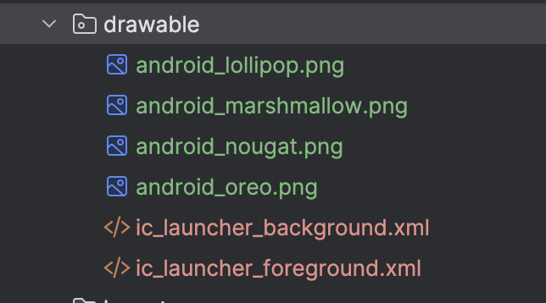

Output:

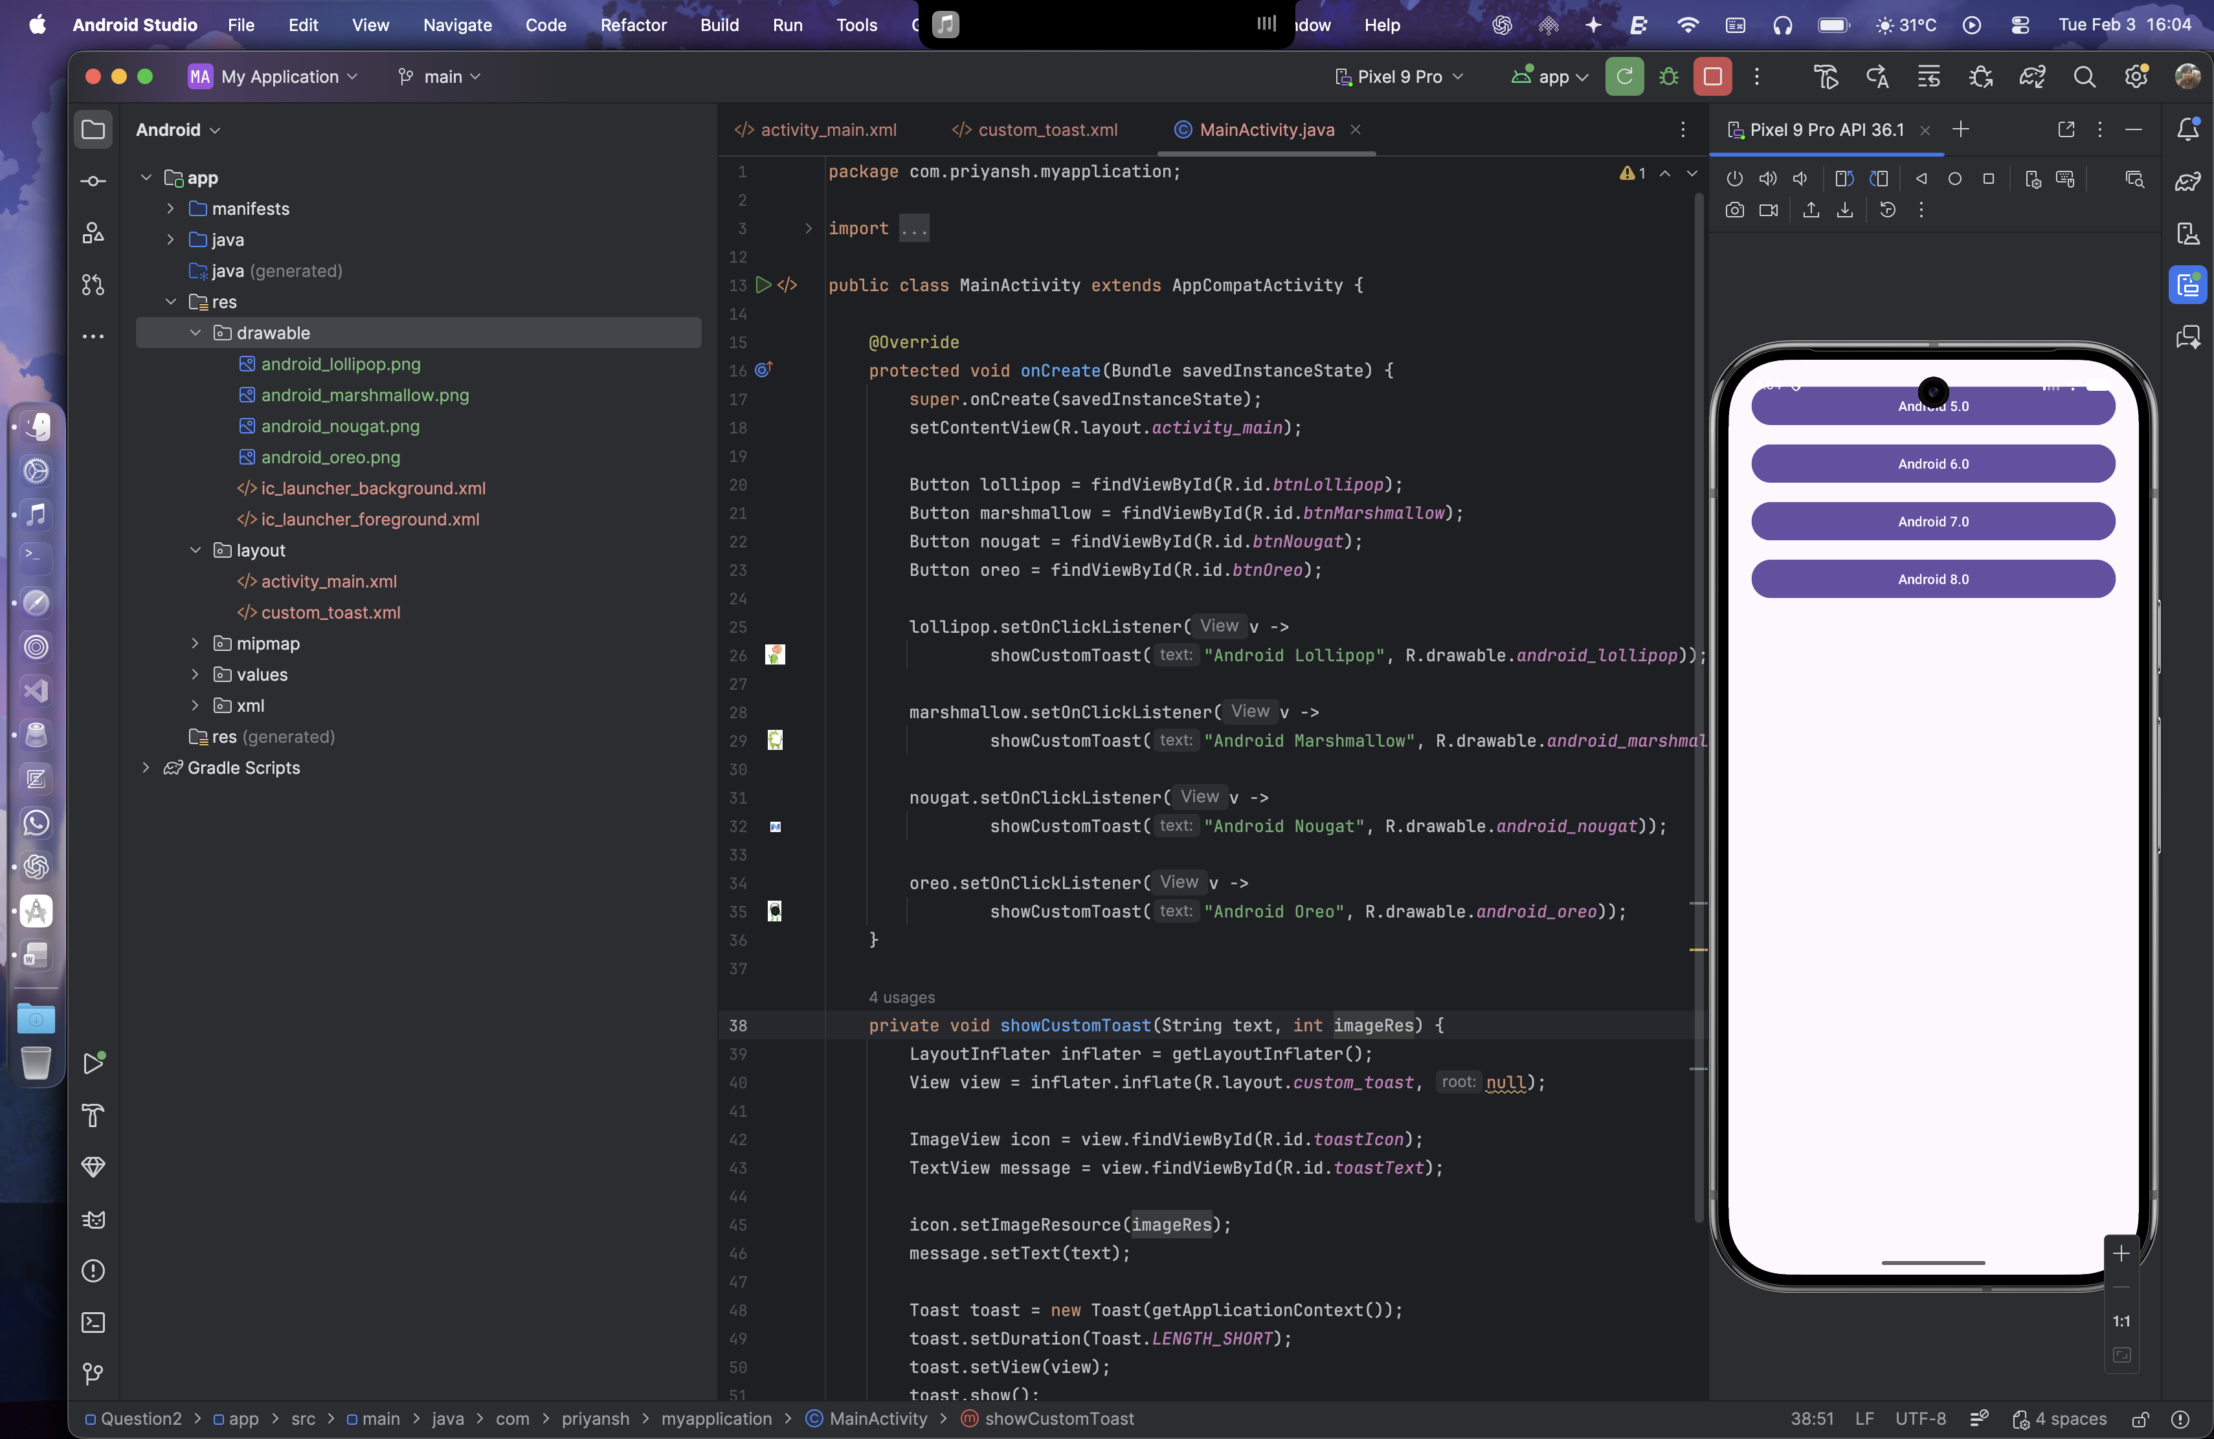 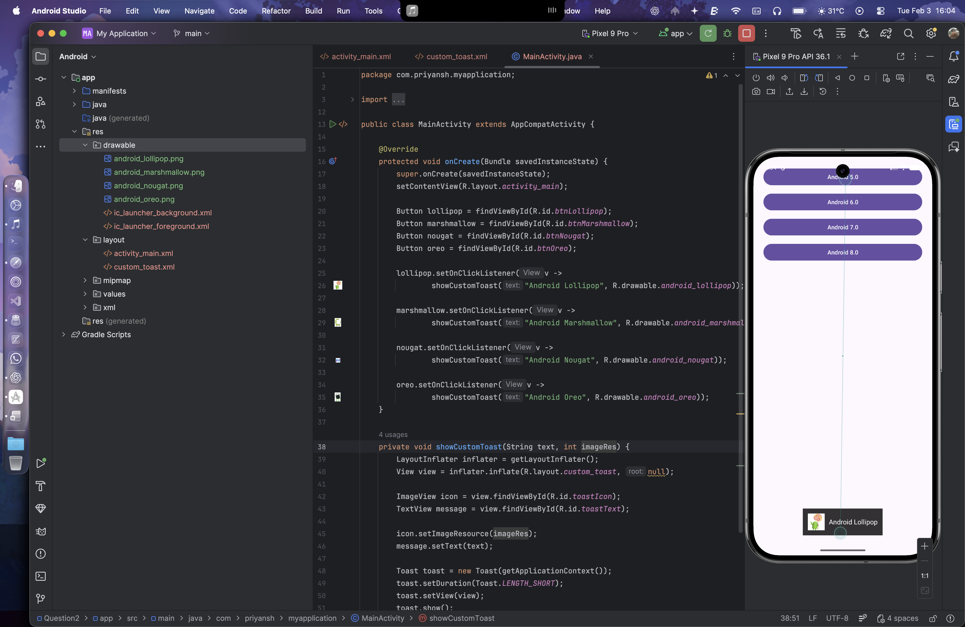 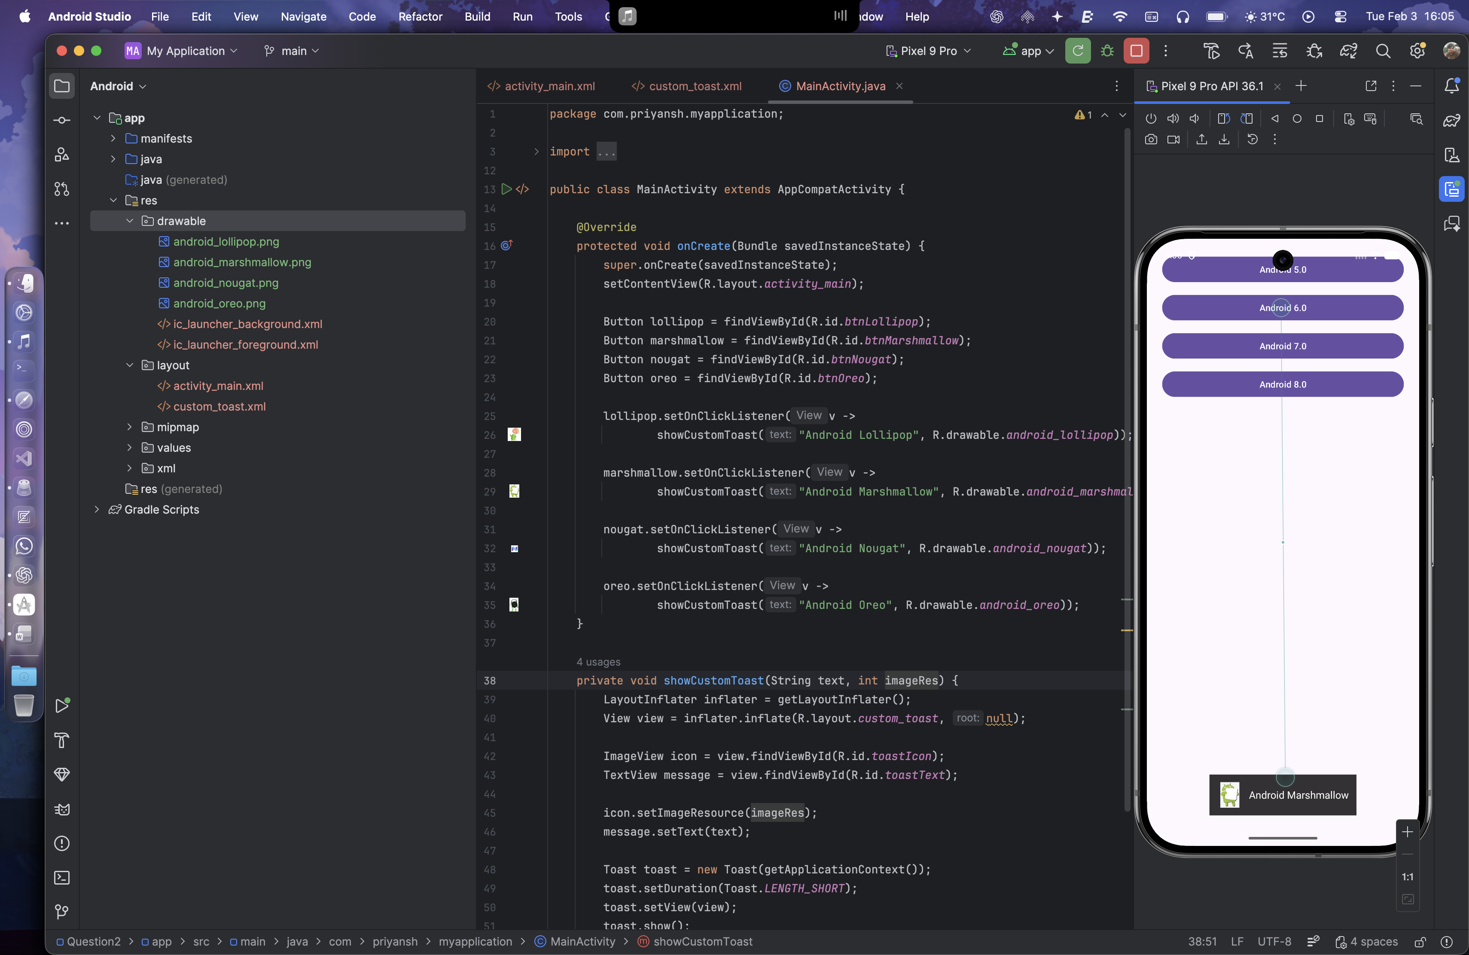 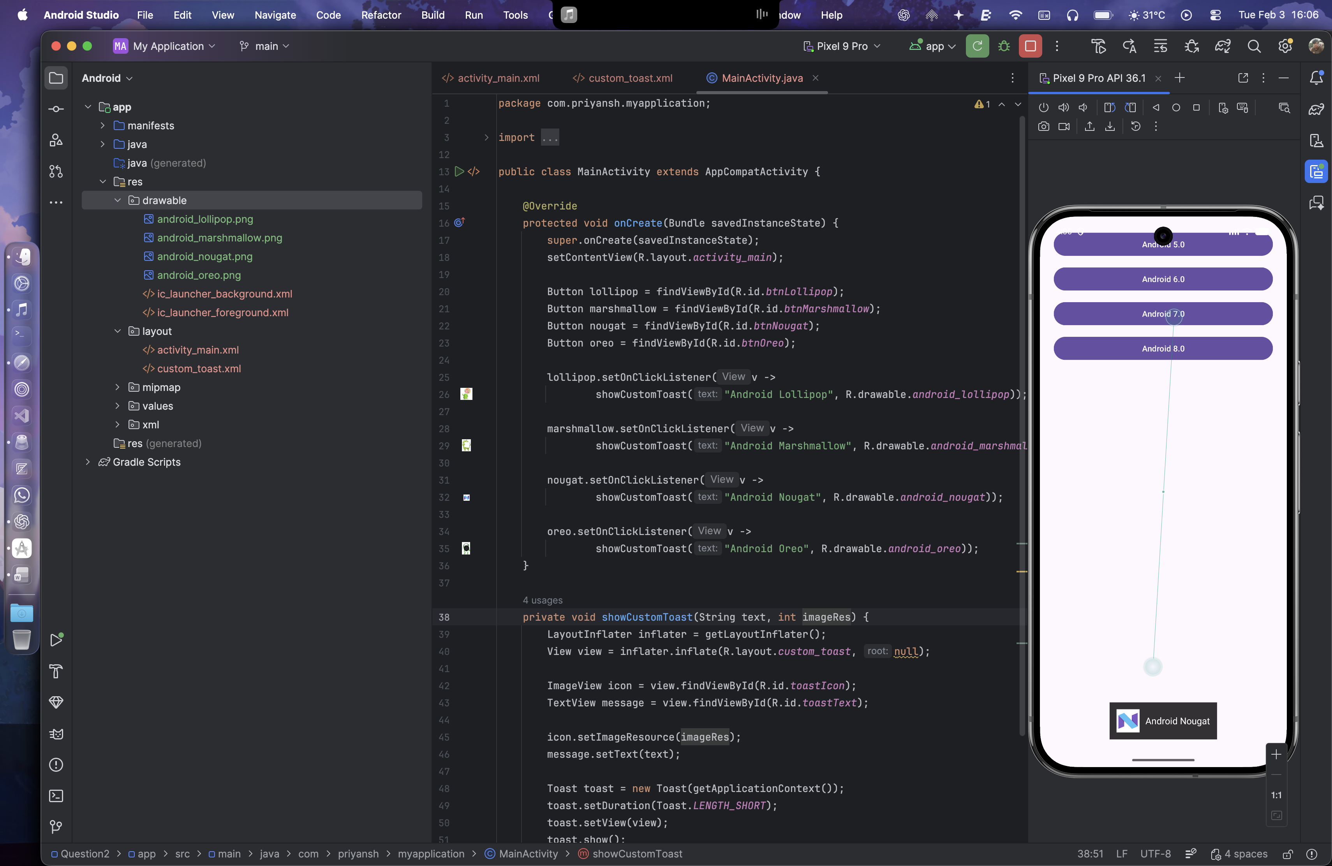 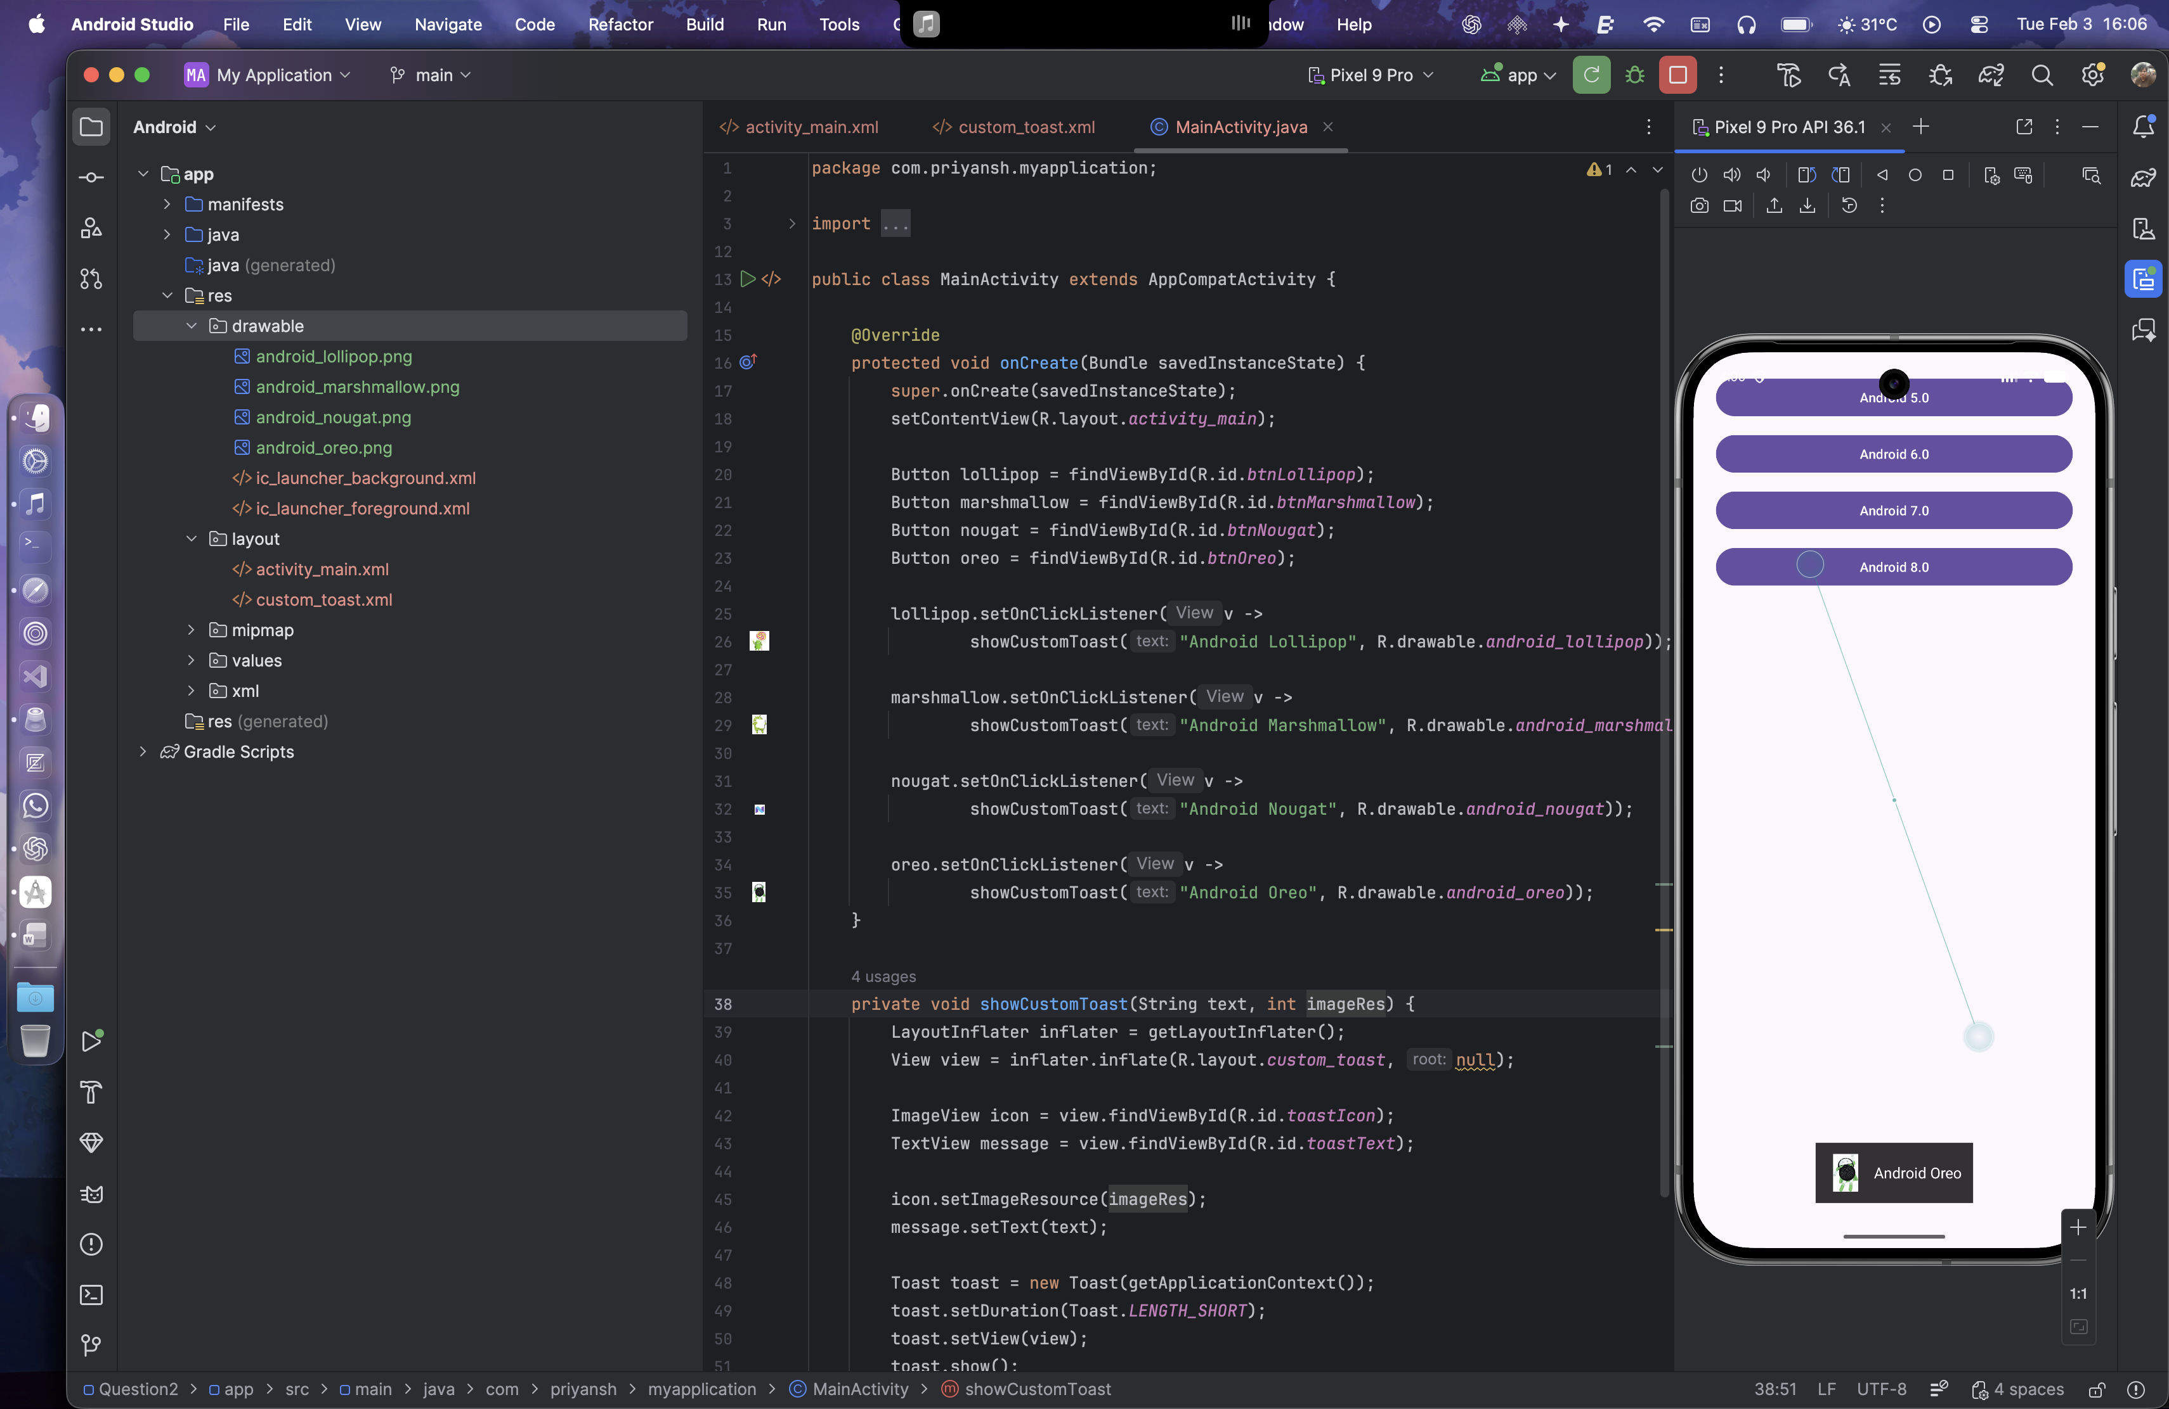

Question 3:

Develop a view with a ToggleButton labeled "Current Mode" that has two states: "Wi-Fi" and "Mobile Data." Based on the state of the toggle button, an image corresponding to the selected mode should appear, and a Toast message should display the current mode. Additionally, when the user clicks the "Change Mode" button, the app should switch to the corresponding mode and update the image accordingly.

Layout Design:

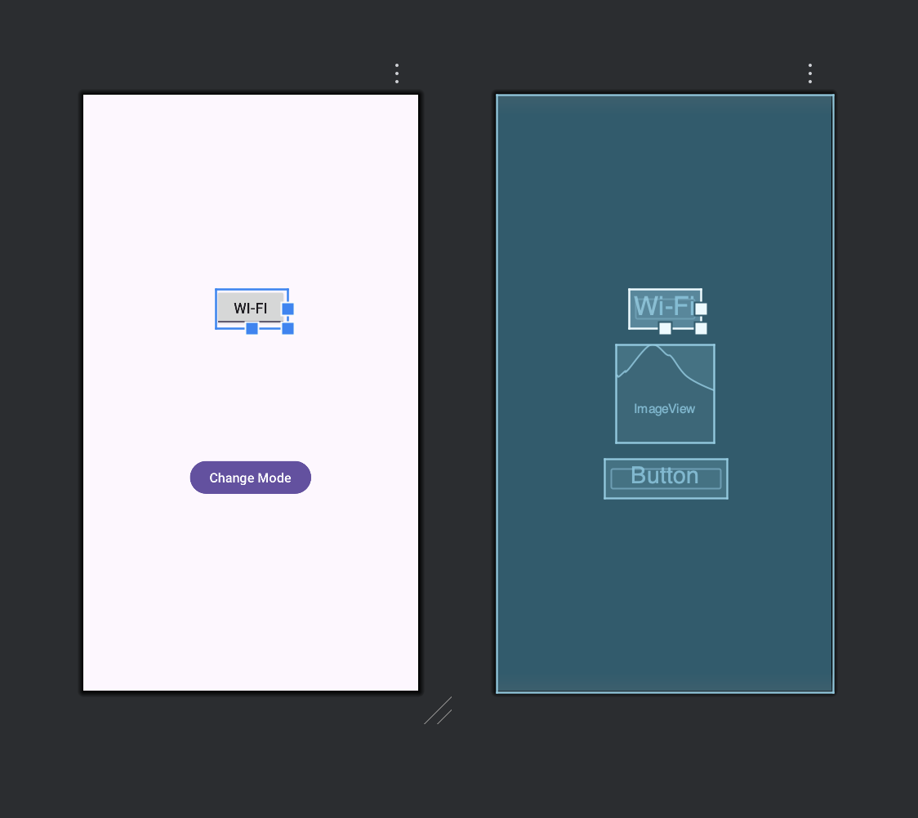

XML for activity_main.xml

<?xml version="1.0" encoding="utf-8"?>  
<LinearLayout xmlns:android="http://schemas.android.com/apk/res/android"  
 android:layout_width="match_parent"  
 android:layout_height="match_parent"  
 android:orientation="vertical"  
 android:gravity="center"  
 android:padding="24dp">  
  
 <ToggleButton  
 android:id="@+id/toggleMode"  
 android:layout_width="wrap_content"  
 android:layout_height="wrap_content"  
 android:textOn="Wi-Fi"  
 android:textOff="Mobile Data"  
 android:checked="true"  
 android:textSize="18sp"  
 android:layout_marginBottom="20dp"/>  
  
 <ImageView  
 android:id="@+id/modeImage"  
 android:layout_width="120dp"  
 android:layout_height="120dp"  
 android:layout_marginBottom="20dp"  
 android:contentDescription="Mode Image"/>  
  
 <Button  
 android:id="@+id/btnChangeMode"  
 android:layout_width="wrap_content"  
 android:layout_height="wrap_content"  
 android:text="Change Mode"  
 android:textSize="16sp"/>  
  
</LinearLayout>

Java Code:

import androidx.appcompat.app.AppCompatActivity;  
  
public class MainActivity extends AppCompatActivity {  
  
 ToggleButton toggleMode;  
 ImageView modeImage;  
 Button btnChangeMode;  
  
 @Override  
 protected void onCreate(Bundle savedInstanceState) {  
 super.onCreate(savedInstanceState);  
 setContentView(R.layout.*activity_main*);  
  
 toggleMode = findViewById(R.id.*toggleMode*);  
 modeImage = findViewById(R.id.*modeImage*);  
 btnChangeMode = findViewById(R.id.*btnChangeMode*);  
  
 updateUI(toggleMode.isChecked());  
  
 toggleMode.setOnClickListener(v -> {  
 updateUI(toggleMode.isChecked());  
 });  
  
 btnChangeMode.setOnClickListener(v -> {  
 toggleMode.setChecked(!toggleMode.isChecked());  
 updateUI(toggleMode.isChecked());  
 });  
 }  
  
 private void updateUI(boolean isWifi) {  
 if (isWifi) {  
 modeImage.setImageResource(R.drawable.*wifi*);  
 Toast.*makeText*(this, "Current Mode: Wi-Fi", Toast.*LENGTH_SHORT*).show();  
 } else {  
 modeImage.setImageResource(R.drawable.*mobile_data*);  
 Toast.*makeText*(this, "Current Mode: Mobile Data", Toast.*LENGTH_SHORT*).show();  
 }  
 }  
}

Images are stored in the drawable folder

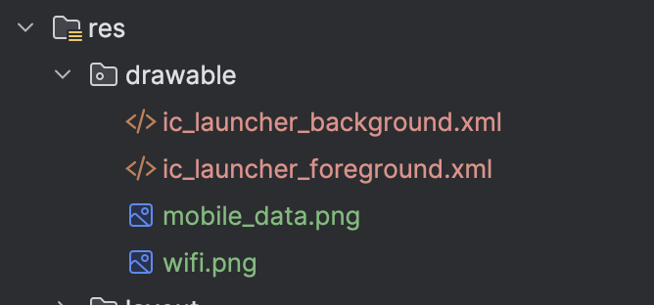

Output:

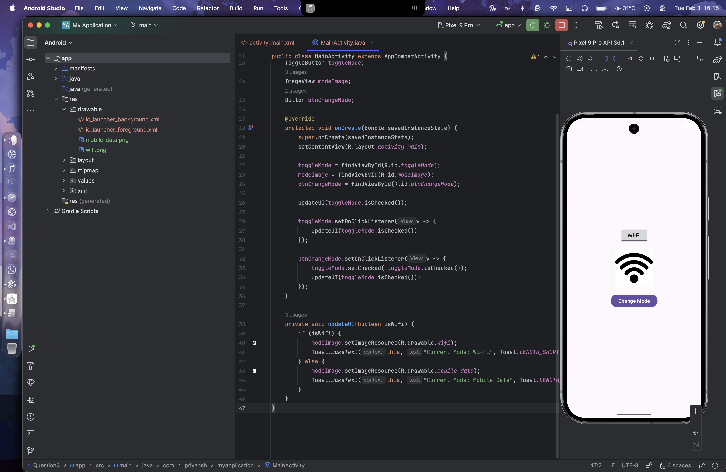 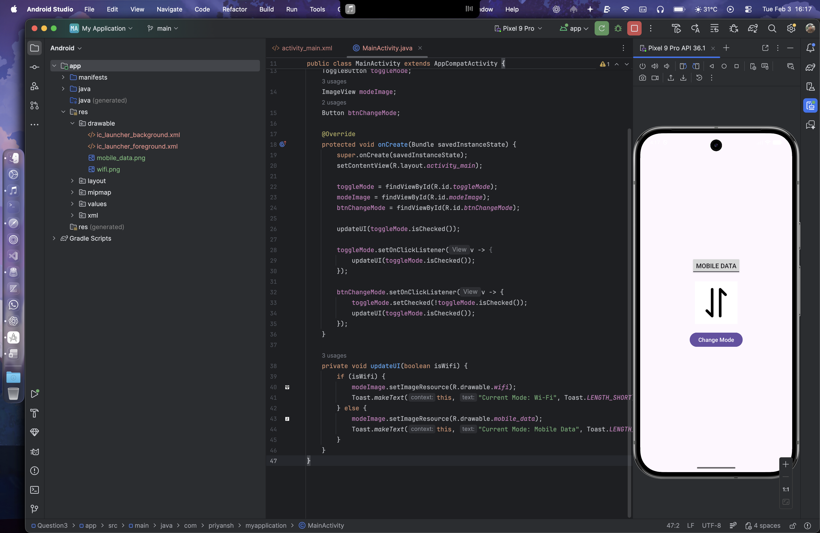

Question 4:

Create a “Food Ordering App” which lists food items with check boxes. Once the user checks/unchecks the item and click on the submit button display the items ordered along with cost of each item and total cost in a new activity. Once the user clicks on the submit button he/she should not be allowed to change the order i.e. he should not be allowed to change the state of the items checked.

Layout Design

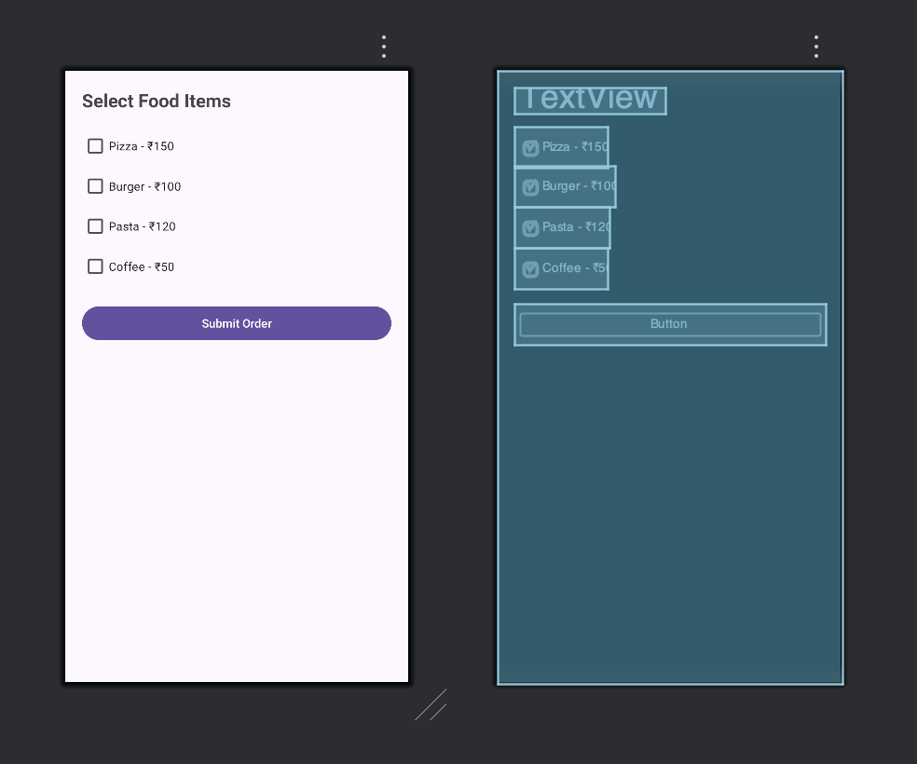

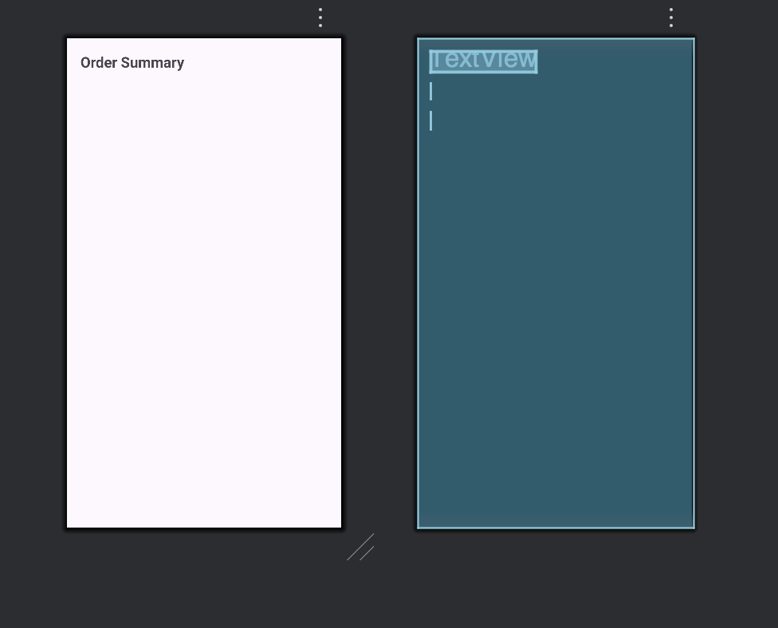

XML for activity_main.xml

<?xml version="1.0" encoding="utf-8"?>  
<LinearLayout xmlns:android="http://schemas.android.com/apk/res/android"  
 android:layout_width="match_parent"  
 android:layout_height="match_parent"  
 android:orientation="vertical"  
 android:padding="20dp">  
  
 <TextView  
 android:layout_width="wrap_content"  
 android:layout_height="wrap_content"  
 android:text="Select Food Items"  
 android:textSize="22sp"  
 android:textStyle="bold"  
 android:layout_marginBottom="16dp"/>  
  
 <CheckBox  
 android:id="@+id/cbPizza"  
 android:layout_width="wrap_content"  
 android:layout_height="wrap_content"  
 android:text="Pizza - ₹150"/>  
  
 <CheckBox  
 android:id="@+id/cbBurger"  
 android:layout_width="wrap_content"  
 android:layout_height="wrap_content"  
 android:text="Burger - ₹100"/>  
  
 <CheckBox  
 android:id="@+id/cbPasta"  
 android:layout_width="wrap_content"  
 android:layout_height="wrap_content"  
 android:text="Pasta - ₹120"/>  
  
 <CheckBox  
 android:id="@+id/cbCoffee"  
 android:layout_width="wrap_content"  
 android:layout_height="wrap_content"  
 android:text="Coffee - ₹50"/>  
  
 <Button  
 android:id="@+id/btnSubmit"  
 android:layout_width="match_parent"  
 android:layout_height="wrap_content"  
 android:text="Submit Order"  
 android:layout_marginTop="20dp"/>  
  
</LinearLayout>

XML for activity_order_summary.xml

<?xml version="1.0" encoding="utf-8"?>  
<LinearLayout xmlns:android="http://schemas.android.com/apk/res/android"  
 android:layout_width="match_parent"  
 android:layout_height="match_parent"  
 android:orientation="vertical"  
 android:padding="20dp">  
  
 <TextView  
 android:layout_width="wrap_content"  
 android:layout_height="wrap_content"  
 android:text="Order Summary"  
 android:textSize="22sp"  
 android:textStyle="bold"  
 android:layout_marginBottom="16dp"/>  
  
 <TextView  
 android:id="@+id/tvOrderDetails"  
 android:layout_width="wrap_content"  
 android:layout_height="wrap_content"  
 android:textSize="18sp"  
 android:layout_marginBottom="20dp"/>  
  
 <TextView  
 android:id="@+id/tvTotalCost"  
 android:layout_width="wrap_content"  
 android:layout_height="wrap_content"  
 android:textSize="20sp"  
 android:textStyle="bold"/>  
</LinearLayout>

Java Code:

MainActivity.java

public class MainActivity extends AppCompatActivity {  
  
 CheckBox cbPizza, cbBurger, cbPasta, cbCoffee;  
 Button btnSubmit;  
  
 @Override  
 protected void onCreate(Bundle savedInstanceState) {  
 super.onCreate(savedInstanceState);  
 setContentView(R.layout.*activity_main*);  
  
 cbPizza = findViewById(R.id.*cbPizza*);  
 cbBurger = findViewById(R.id.*cbBurger*);  
 cbPasta = findViewById(R.id.*cbPasta*);  
 cbCoffee = findViewById(R.id.*cbCoffee*);  
 btnSubmit = findViewById(R.id.*btnSubmit*);  
  
 btnSubmit.setOnClickListener(v -> {  
 StringBuilder orderDetails = new StringBuilder();  
 int totalCost = 0;  
  
 if (cbPizza.isChecked()) {  
 orderDetails.append("Pizza - ₹150\n");  
 totalCost += 150;  
 }  
 if (cbBurger.isChecked()) {  
 orderDetails.append("Burger - ₹100\n");  
 totalCost += 100;  
 }  
 if (cbPasta.isChecked()) {  
 orderDetails.append("Pasta - ₹120\n");  
 totalCost += 120;  
 }  
 if (cbCoffee.isChecked()) {  
 orderDetails.append("Coffee - ₹50\n");  
 totalCost += 50;  
 }  
  
 Intent intent = new Intent(MainActivity.this, activity_order_summary.class);  
 intent.putExtra("order", orderDetails.toString());  
 intent.putExtra("total", totalCost);  
 startActivity(intent);  
  
 disableInputs();  
 });  
 }  
  
 private void disableInputs() {  
 cbPizza.setEnabled(false);  
 cbBurger.setEnabled(false);  
 cbPasta.setEnabled(false);  
 cbCoffee.setEnabled(false);  
 btnSubmit.setEnabled(false);  
 }  
}

activity_order_summary.java

public class activity_order_summary extends AppCompatActivity {  
  
 @Override  
 protected void onCreate(Bundle savedInstanceState) {  
 super.onCreate(savedInstanceState);  
 setContentView(R.layout.*activity_order_summary*);  
  
 TextView tvOrderDetails = findViewById(R.id.*tvOrderDetails*);  
 TextView tvTotalCost = findViewById(R.id.*tvTotalCost*);  
  
 String order = getIntent().getStringExtra("order");  
 int total = getIntent().getIntExtra("total", 0);  
  
 tvOrderDetails.setText(order.isEmpty() ? "No items selected" : order);  
 tvTotalCost.setText("Total Cost: ₹" + total);  
 }  
}

Output:

